$\overline{P}$$\overline{P}$“DMAIC FL_UE: application of revised tools for the study and optimization of materials flows in a metalworking company”

Abstract: The DMAIC cycle is a powerful framework that ensures a data-driven approach for improving, optimizing and stabilizing business processes and design phases. DMAIC - Define, Measure, Analyze, Improve and Control - suggests the adoption of standard and specific tools for each phase. In this work an improved methodology is proposed, called “DMAIC FL_UE” (FLow_valUE). According to the DMAIC FL_UE methodology, traditional mapping tools have been reorganized and new ones have been proposed. Subsequently, the current state of material flows was analyzed in a production company of the metalworking industry. Through the use of the DMAIC FL_UE tools, it was possible to analyze the flows of raw materials and products, highlighting many critical issues to be solved and stages to be optimized; in particular: many unnecessary handling activities managed by internal suppliers; big quantities of materials ordered by internal planners; a very low digitization and integration of production information. Therefore, starting from the photograph of the actual problems present in the process, possible solutions are suggested to the company in order to reduce the lead time and the storage of materials, that means to reduce the invested capital and to increase the elasticity and flexibility to satisfy the market demand.
Keywords: Lean tools, materials mapping, handling and storage, flow value analysis.
Introduction
Material flows tell us a lot about how production is organized. Starbek and Menart (2000) studied the optimization of material flows in production and they understood that too high costs are a result of irrational and too long material flows in the production process. Therefore, it becomes important to identify the activities that absorb resources but don’t create value, adding only time and cost. Nicholas (1998) found that waste takes many forms. Instead, Russell and Taylor (1999) define “waste” as anything over the minimum amount of equipment, effort, materials, parts, space and time that are essential to add value to the product. Lean Manufacturing (LM) is the systematic approach to identify and eliminate “wastes” (non-value added activities) through continuous improvement (NIST, 2000). Lean Manufacturing is based on the fundamental goals of Toyota Production System (TPS), which aims to minimize wastes and to speed up flows (Hines and Rich, 1997; Vinodh et al., 2010). According to TPS, the seven most common wastes are: overproduction, transport, waiting, inappropriate processing, unnecessary inventory, motion and defects (Ohno, 1988). More recently, another waste is considered: non-utilized talent, that means underutilizing people’s talents, skills and knowledge.
In this paper, we focused on the following three main wastes: transport, unnecessary inventory and motion. The idea is to suggest a new approach and revised tolls to investigate the “stop and go” moments for materials along the process. The final objective is to propose an agile approach for projects of improving, to decrease the “stop” and increase the “go” of materials inside the company (Petrillo, 2018).

1. DMAIC overview
To achieve the excellence in implementing LM in different organizations, many studies propose the use of various principles, techniques and tools (Jasti et al., 2012; Piercy and Rich, 2009); even if few researchers have proposed very new aspects (Anand and Koladi, 2010); while, many researchers have performed some revisions and integrations of well-known elements (Pettersen, 2009; Papadopoulou and Ozbayrak, 2005). Instead, in agreement with other authors (Shah and Ward, 2003 and 2007; Singh and Sharma, 2009), LM uses very often the same main tools and techniques: value stream mapping, 5S, kaizen, kanban, total productive maintenance, poka yoke etc., to identify and remove wastes from any process.
Value Stream Mapping (VSM) is one of the most powerful tools used in LM (Abdulmalek and Rajgopal, 2007). VSM is a technique for analyzing the flow of materials and the linked flow of information, based on the language of symbols (Jones and Womack, 2000). VSM is a graphic mapping of all the activities and stages that contribute to the realization of a product or service, starting from the supplier of raw materials up to the delivery of finished products to the customer; the technique also identifies all the value-added and non-value-added activities along the process (Rosentrater and Balamuralikrishna, 2006).
According to Monden (1993), there are three different possibilities for mapping activities:
(1) non-value adding (NVA);
(2) necessary but non-value adding (NNVA) or so called business value-adding (BVA);
(3) value-adding (VA).
The first type is pure waste and involves actions which should be eliminated completely. Examples are: waiting times, stacking of intermediate products and double handlings. Necessary but non-value adding operations may be wasteful but are necessary for the operating procedures. Examples would include: walking long distances to pick up parts, unpacking deliveries and transferring a tool from one hand to another. These types of operations can be eliminated but it would be often necessary to make major changes to the operating system such as creating a new layout, for example using simulation (Falcone at al., 2013). Such changes may not be possible immediately. Finally, value-added operations are all the activities that involve the transformation of raw materials or semi-finished products. Those type of activities is simply recognized by the final customer, contributing to increase his satisfaction, therefore he pays for them.
However, according to Bhamu and Sangwan (2014), to provide feasible solutions, LM requires the adoption of the DMAIC approach in applying the above tools, to map, improve and optimize the process. In agreement with De Mast J and Lokkerbol (2012), DMAIC (Define, Measure, Analyze, Improve and Control) is an effective problem-solving method in Six Sigma strategy; it provides a structured problem-solving procedure, and it is suitable for many tasks.
The present work proposes a methodology derived from the DMAIC cycle focused on the optimization of materials flow, in particular on “stop and go” moments along the process. The article is organized as follows: the section two introduces the proposed methodology called “DMAIC FLow_valUE”: DMAIC FL_UE. The section three is about the application of this new methodology in a mechanical company to analyze material handlings through many tools: flowchart, flow process chart, spaghetti chart, value stream mapping. The previous tools are customized and applied to the particular case-study, even if they are developed in a general way. The section four discusses the critical issues encountered and the proposals for their improvement. Conclusions and future developments complete the article.

2. Proposed methodology: DMAIC FL_UE
This work presents a methodology derived from the DMAIC cycle, called DMAIC FL_UE. That methodology starts from the study of the DMAIC cycle, derived from Deming’s PDCA cycle and divided into five sequential phases: Define, Measure, Analyze, Improve and Control. DMAIC FL_UE considers three different points of view:
- Physical flow;
- Information flow;
- Materials storage.
The aim is to propose tools to optimize materials flow and storage.
So, in the DEFINE phase, the physical handling of materials is studied and the materials path mapped.
In the MEASURE phase, it essential to make the transition from a simple descriptive/qualitative mapping to a quantitative one, necessary to indicate the number of moved handling units (e.g. boxes). The ANALYZE phase is the core of the proposal, in fact some tools more suitable for the objective were identified and their sequence of application. In particular, the following graphical tools are considered:
- Flowchart or Block diagram
- Revised single-product flow process chart
- Weighted spaghetti chart
- Revised value stream mapping
The proposed approach is represented in the figure n. 1.
Figure 1: DMAIC FL_UE Methodology

This methodology concerns the three initial phases of the original DMAIC cycle: Define, Measure and Analyze.
In general, the first two stages of DMAIC allow “setting” the problem and from the third stage the “solving” procedure starts. Then, in the next phase - IMPROVE - it will be possible to identify and implement all the improving actions. The CONTROL phase can only take place at the end of the IMPROVE phase, to sustain the obtained results.

3. Application in a metalworking company
The case study was carried out in one of the leader companies of products, solutions and services in the metalworking sector.
The production plant consists of several areas:
- Warehouse 1
- Warehouse 2
- MST turnery
- Indirect materials warehouse
- Shunting goods area
- Tempered pull stand
- Turned pull stand
- Yard for unloading
- Assembly lines pull stand
- Unloading yard for non-scheduled trucks
- Warehouse of oils and fats
- Feedstock buffer.
The analysis of material handlings focused on several areas that will be referred in following sections.

3.1 Materials flow analysis
In the paper, the most significant examples of the DMAIC FL_UE application is shown, even if other application were realized in the investigated firm; the materials are identified in a generic way. In particular, three examples of the application of the proposed methodology and related tools are shown in the following: Product A and Product B-Type X and Type Y.
- Product A
- Flowchart or Block Diagram
Product A comes into the plant and it is unloaded by the operators of external suppliers. Then a visual check is performed to verify if the content is complainant with the transport document, then the operators assign the products to the various work stations. Then, two cases are possible: the material is not necessary in production or it is. In the first case the material is directly allocated in the warehouse, in the second case the material is allocated in a buffer far about 20 m from the production lines. Those operations are represented in the figure n. 2.
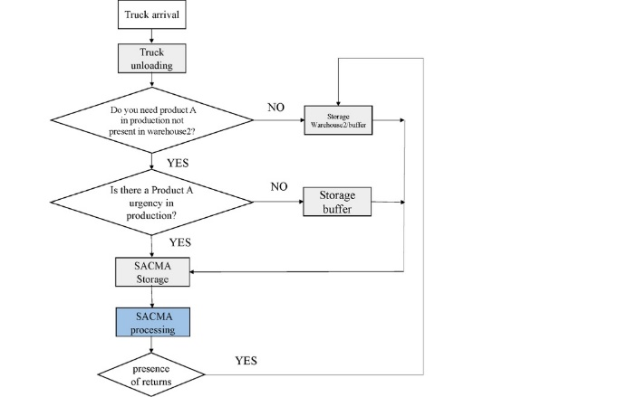Figure 2: Example of Flowchart – Product A

- Revised Single-product Flow Process Chart
In the second stage, a revision of the single-product flow process chart is proposed. In particular, according to the classification of activities into VA; NNVA or BVA; NVA, in the sheet the different value of each activity is highlighted using different colours. In this way it is immediately evident where the problems are present along the process.
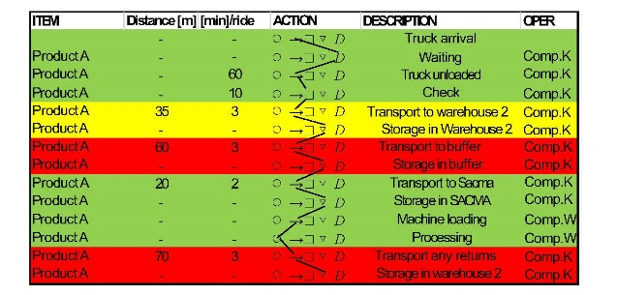Figure 3: Example of Revised single product flow process chart – Product A
In the figure n. 3 the sheet has been modified, highlighting the various types of operations with different colours, considering the ASME symbols. In particular, the good actions are represented in green (VA), the actions that should be eliminated in red (NVA), while the actions that are not VA and that could be reduced in yellow (NNVA or BVA). Product A arrives 2-3 times a month with non-scheduled trucks, so the following considerations refer to a single arrival, the period of observation was two weeks. Furthermore, the transport of the raw material (Product A) from the warehouse 1 to the processing buffer or to the pull stand, doesn’t take place daily but according to specific requirements.
- Spaghetti Chart
The starting point is the collection of data of all handling activities from one point to another inside the firm; the representation of them on the layout of the plant. The spaghetti chart of Product A is shown in the figure n. 4.
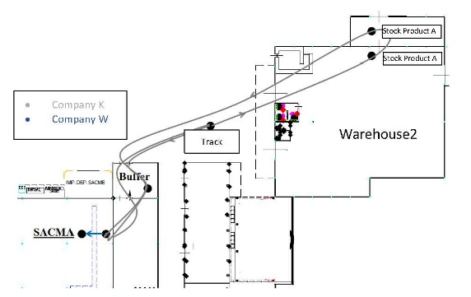
Figure 4: Example of Spaghetti Chart – Product A
At the beginning of the analysis only a qualitative spaghetti chart was possible to draw, because the available data on the number of boxes were insufficient. Therefore, it was necessary to define data entry supports to collect more information to shift from a qualitative spaghetti chart to a quantitative one, called weighted spaghetti chart as showed in the following example.
- Revised Value Stream Mapping
Finally, we drew the value stream mapping, starting from the current state of the process. In the same way of the revised single-product flow process chart, in the construction of the Lead Time ladder at the bottom of VSM, three different colours and levels are used to show VA; NNVA or BVA; and NVA activities (respectively green; yellow and red)
The revised VSM of Product A is represented in the figure n. 5.
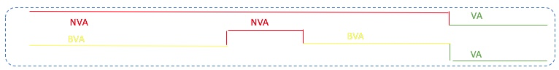Figure 5: Example of Revised Value Stream Mapping – Product A
According to the traditional two-levels analysis (upper Time Line ladder at the bottom of VSM in the figure n. 5), it is possible to note that the only value-added action is given by the process box of the product, instead using the three-levels analysis (lower Time Line ladder at the bottom of VSM in the figure n. 5) it is possible to carry out a deeper knowledge of the process. So, the storage in the pull stand is a non-added value action, but it turns yellow because this action cannot be avoided without modifying the plant layout. The non-value-added operation are the storage of intermediate products before going to the processing pull stand, in an intermediate warehouse - the buffer – with picking actions to be brought to the pull stand only when necessary. This operation is almost useless, it could be eliminated to facilitate the straight transition between warehouse and pull stand.
- Product B
Product B can be divided into two types: X and Y. Type X requires more processing activities than type Y and, consequently, the additional storage in another pull stand.
Product B - Type X
If the material is required by the production line, it is allocated in the pull stand, otherwise it is allocated in the warehouse 1 or in the unloading area, if the space in the warehouse 1 is not available. These operations are represented in the figures nn. 7 and 8.
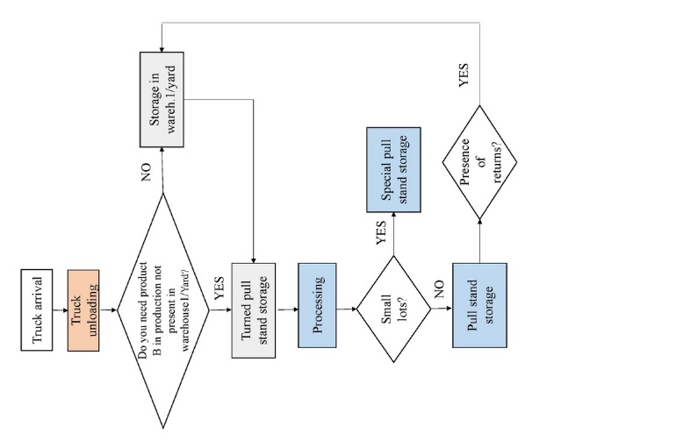
Figure 6: Example of Flowchart – Product B-Type X
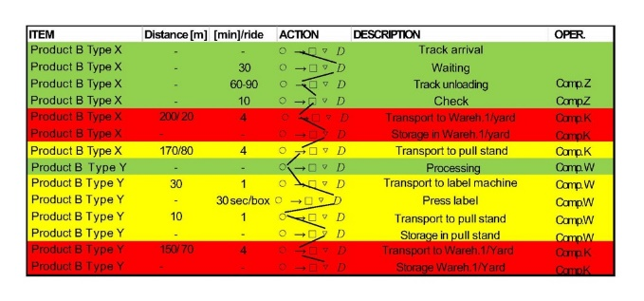Figure 7: Example of Revised single product flow process chart – Product B-Type X

The analysis of the quantities of boxes that daily arrive, was carried out considering two different weeks of observation. Considering the data of the first week, 444 boxes arrived, but only the 4% of them, represented Product B-Type X.
The figure n. 8 shows the weighted spaghetti chart of Product B-Type X, with the percentage of the boxes for each path:
- 70% is transported directly to the lines as soon as the truck arrives;
- 15% is stored in the warehouse 1;
- 15% is left in the unloading area.
Another possibility offered by the weighted spaghetti chart is the visualization of the different operators involved. Therefore, in the chart different colours are used to highlight also the different companies responsible of managing the boxes of material.
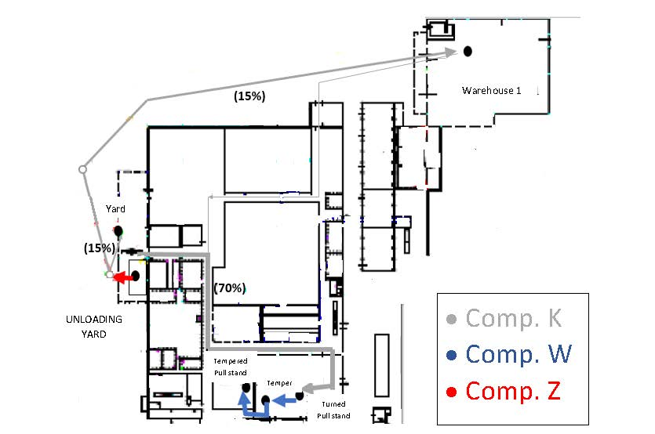Figure 8: Example of Weighted spaghetti Chart - Product B-Type X

The revised VSM of Product B-Type X is represented in the figure n. 9. In this case, big attention is put to the information flow at the bottom of the drawing, linked to the physical flow of the materials.
In particular, the figure n. 9 shows:
- the transport document indicating the quantities of boxes and their content;
- the paper form containing information on the number of boxes in the pull stands at the head of the lines and the number of boxes coming back to the warehouse from the line;
- the paper form relating to the "daily requirement" and the daily productive Gantt.
Figure 9: Example of Revised Value Stream Mapping – Product B-Type X
Product B - Type Y
When this type of products arrives, if it is required by the production line, it is allocated in the pull stand, otherwise it is transported to the warehouse 1 or left in the unloading area. Those operations are represented in the figures nn. 10 and 11.
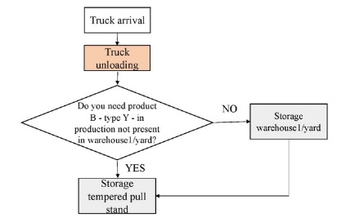
Figure 10: Example of Flowchart – Product B-Type Y
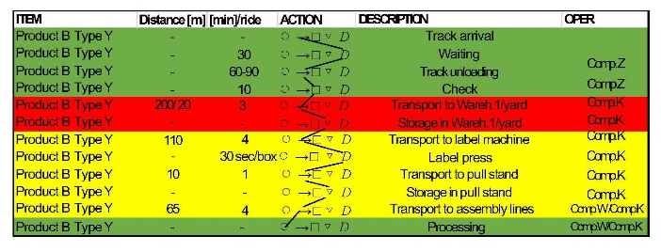Figure 11: Example of Revised single product flow process chart. Product B-Type Y
In the second week of observation, Product B-Type Y represents the 60% of the 444 boxes arrived, with an average of 54 boxes per day.
The figure n. 12 shows the different percentages of distribution of Product B-Type Y for each path:
- 39% is sorted within the various pull stands in the production area;
- the remaining 61% is stored as follows: 57% remains at the yard, used as a warehouse, while 4% is transported to the warehouse 1.
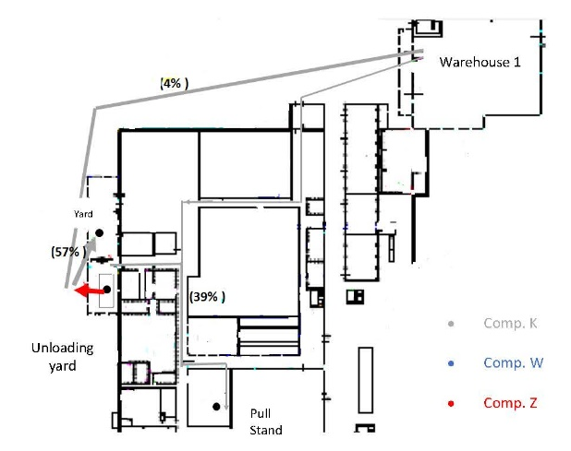
Figure 12: Example of Weighted Spaghetti Chart – Product B-Type X
Analysing the collected data, it is possible to verify that the warehouse 1, in which all the boxes should be stored, has not been suitably dimensioned; this is the reason of finding a lot of materials in the unloading area. In fact, in the warehouse there are many obsolete materials that take up space. The information flow is almost identical to that described before for Product B-Type X. In the figure n. 13 the revised VSM of Product B-Type Y is represented. Figure 13: Value Stream Mapping – Product B Type X

- Critical issues and proposals
Thanks to the conducted analysis, many critical issues have been identified. Those critical issues must be solved in order to realize an optimal management of material flow and storage. In particular:
- Returns. The forklift drivers of the companies K and Z carry out empty transports, even if in limited numbers; this aspect causes a flow that is not optimized. Those operators move into the direction opposite to the main flow, towards the warehouse 1 and the unloading area. These are returns with a low payload or often without at all, causing totally useless handling acts.
- Intermediate buffer for Product A. The corridors and the warehouse 2 are the areas with less material, they could be used as buffers. In fact, by avoiding the transit towards that processing buffer, the time spent in useless handling acts can be avoided.
- Materials placed in the unloading yard. For Product B there is a particular situation: the warehouse 1, where it should actually be located, is sometimes full and for the types X and Y there is not enough space. For this reason, the operator of the company K is forced to place Product B “temporarily” inside the yard (until the space in the warehouse 1 is created).
- External suppliers inside the firm. The use of operators of suppliers makes the plant highly dependent on them. On the other hand, the external suppliers operating inside the firm are not aware of multiple aspects that determine an optimal functioning of the company itself. The plant, for example, is not aware of the real stock of the material inside the warehouses, in particular in the warehouse 1. Then, if the activity of those operators should suddenly stop, this would have many consequences and would have a significant impact on the production. The material present in the warehouse should be easily identifiable and easily manageable. The company must be aware at all times of the exact position of the materials thanks also to the adoption of new software tools.
- Lack of information. The operators often use only a visual management of materials. Starting from the counting of the boxes in the pull-stand, up to the control of all materials that arrive with the truck. This task is assigned to a single person with wastes of time; moreover, the human labour is easily subject to error; therefore, an appropriate digitalization process is necessary, adopting new solutions, also provided by Industry 4.0 technologies. In this way the operator could directly find the information he needs in the cloud, for example. In the company, there isn’t a software that, based on the quantities already present in the pull stands or along the assembly lines and based on the master production planning, directly suggests how much material to handle or order.

- Conclusions
In the present work, starting from Flow Value Analysis, an integrated methodology has been proposed and applied within a metalworking company, called DMAIC FL_UE. In particular, the application allows studying material management problems from different perspectives. Revisited graphical tools to optimize the flow and storage of materials have been developed. Both physical flows of materials and information flows are investigated, linked to all the movements of the materials and their storage. Consequently, Non-Value Added activities (unnecessary activities like delays and movements), Value Added activities (for which the customer pays) and also Business Value Added activities (that the customer does not see, but necessary for the process) were highlighted thanks to the proposed tools.
The adoption of some graphical tools joined together to analyze problems, makes the methodology very powerful to suggest possible solutions for optimizing the management of materials.
Continuing the integration of different tools, the future step will be to dimension pull stands, according to the previous analysis and through the application of Little’s law.
References
Starbek, M.; Menart, D. (2000). The optimization of material flow in production. International Journal of Machine Tools and Manufacture. 40 (9), 1299-1310.
Nicholas, J. (1998). Competitive Manufacturing Management: Continuous Improvement, Lean Production and Customer-Focused Quality. Irwin/McGraw-Hill, New York, NY.
Russell, R.S. and Taylor, B.W. (1999). Operations Management, 2nd ed. Prentice-Hall, Upper Saddle River, NJ
NIST Manufacturing Extension Partnership Lean (2000). Lean Certificate Series. Gaithersburg, MD.
Hines, P. and Rich, N. (1997). The seven value stream mapping tools. International Journal of Operations and Production Management, Vol. 17, 46-64.
Vinodh, S., Arvind, K.R. and Somanaathan, M. (2010). Application of value stream mapping in an Indian camshaft manufacturing organization. Journal of Manufacturing Technology Management. Volume (21), 888–900.
Ohno, T., (1988). Toyota Production System: beyond Large Scale Production. Productivity Press, New York, NY
Petrillo, A., Di Bona, G., Forcina, A., Silvestri, A., (2018). Building excellence through the Agile Reengineering Performance Model (ARPM): A strategic business model for organizations. Business Process Management Journal. Volume 24, Issue 1, 2018, Pages 128-157
Jasti, N.V.K., Sharma, A. and Kodali, R. (2012). Lean to green supply chain management: a case study. Journal of Environmental Research and Design. Vol. 6, 890-899.
Piercy, N. and Rich, N. (2009). Lean transformation in the pure service environment: the case of the call service center. International Journal of Operations & Production Management, Vol. 29, 54-76.
Anand, G. and Kodali, R. (2010). Development of a framework for implementation of lean manufacturing systems. International Journal of Management Practice, Vol. 4, 95-116.
Pettersen, J. (2009). Defining lean production: some conceptual and practical issues. The TQM Journal, Vol. 21, 127-142.
Papadopoulou, T.C. and Ozbayrak, M. (2005). Leanness: experiences from the journey to date. Journal of Manufacturing Technology Management, Vol. 16, 784-807.
Shah, R. and Ward, P.T. (2003). Lean manufacturing: context, practice bundles, and performance. Journal of Operations Management, Vol. 21, 129-149.
Shah, R. and Ward, P.T. (2007). Defining and developing measures of lean production. Journal of Operations Management, Vol. 25, 785-805.
Singh, B. and Sharma, S.K. (2009). Value stream mapping as a versatile tool for lean implementation: an Indian case study of a manufacturing firm. Measuring Business Excellence, Vol. 13, 58-68.
Abdulmalek, F.A. and Rajgopal, J. (2007). Analyzing the benefits of lean manufacturing and value stream mapping via simulation: a process sector case study. International Journal of Production Economics. Vol. 107, 223-236.
Jones, D. and Womack, J. (2000). Seeing the Whole: Mapping the Extended Value Stream. Lean Enterprise Institute, Cambridge, MA.
Rosentrater, K.A. and Balamuralikrishna, R. (2006). Value stream mapping – a tool for engineering and technology education and practice. Proceedings of the 2006 ASEE IL/IN Conference, Fort Wayne, IN, USA.
Monden, Y. (1993). Toyota Production System: An Integrated Approach to Just-in-Time. Industrial Engineering and Management Press, 2nd ed, Norcross, GA.
Falcone, D., Forcina, A., Di Bona, G., Duraccio, V., Silvestri, A., Cerbaso, C. (2013). Technical and economic verification of the convenience in reengineering a production line using simulation techniques. 25th European Modeling and Simulation Symposium, EMSS 2013, Pages 327-332
Bhamu J and Sangwan KS. (2014). Lean manufacturing: literature review and research issues. Int J Oper Prod Manage, 34,876–940.
De Mast J and Lokkerbol J. (2012). An analysis of the six sigma DMAIC method from the perspective of problem solving. Int J Prod Econ, 139,604–614.

