How can productivity in Product Design and Engineering be assessed? Guidelines to build a dashboard of KPIs

Abstract
Productivity is among the most popular and useful measures to control a firm’s performance. It is usually defined as a ratio between a firm’s final outputs and its inputs. Such a definition for productivity does not allow an accurate assessment of those organisational units operating in the early stages of the new product development process, whose outputs are distant from a firm’s final ones. This article focuses on the organisational units operating on product design and engineering activities, considered a key competitive advantage source. Indeed, such units oversee major responsibilities in developing new products and improving existing ones. Therefore, monitoring product design and engineering units’ productivity is of pivotal importance, especially for firms whose business model heavily relies on new or continuously improved products. However, research on the productivity of product design and engineering units has been underdeveloped, and previous studies have called for research on the topic. Hence, this article outlines the features of product design and engineering activities, describing their similarities and differences with respect to research and development activities and to service activities. Consequently, it presents methodological insights to assess product design and engineering productivity and their illustrative implementation in Leonardo SpA, a global company in the Aerospace and Defence sector. Finally, the article outlines the theoretical and managerial implications of the study.
Managerial relevance statement
Assessing the productivity of product design and engineering activities is a key concern for all companies having at least one organisational unit dedicated to the task. Indeed, the standard productivity indicators do not suit the peculiarities of engineering activities, with the result that the assessment of their productivity is often neglected. This article provides detailed guidelines to understand the key factors that need to be considered (including the assessment goal and the role played by inputs, outputs, and outcomes). The article recommends setting up a dashboard to provide managers with a holistic view of product design and engineering multiple outputs and outcomes. As an example, the article also offers an implementation of the method in a high-tech and knowledge-intensive global company.

Keywords - Productivity, Product Design, Product Engineering, New Product Development, Research and Development, Services, Dashboard

Introduction
Many manufacturing firms rely on their capability to develop new products and improve existing ones. Product Design and Engineering (PDE) activities represent the connection between a firm’s research and manufacturing activities. They are typically performed by a team (or even a specific organisational unit) of designers, systems engineers, and other professionals. Since innovative firms’ competitive advantage depends on the PDE activities’ outputs, and since such activities can be expensive and risky, improving their productivity is essential. Flourishing streams of the literature study how to enhance design and engineering activities, such as through lean product development [1]–[3], agile-stage-gate [4], and many other approaches (for a review, see [5]). While most previous studies focused on how to improve PDE activities, assessing PDE productivity remains a known and unresolved challenge [6], [7]. Indeed, consistent definitions for PDE productivity are lacking, and comparable indicators are missing [5]. As Cantamessa suggested [7], simple productivity ratios between quantity measures (e.g., number of projects on used resources) could overlook the importance of quality in PDE. Instead, Drucker [8] observed that the outcome of “knowledge workers” – as those operating in PDE activities – is not primarily a matter of quantity, with quality being “the essence of the output” [8, p. 84], while in manual work quality is a restraint describing minimum acceptable levels.
Despite the relevance of assessing productivity in PDE, the many studies mentioning PDE productivity did not operationalise it e.g., [7], [9], [10]. Yet, innovative firms need reliable measures to assess and improve their PDE activities, identify their moderators, formulate forecasts, and compare them with the results. Several studies acknowledged the literature gap in PDE activities productivity and encouraged future research. Among them, Dekkers et al. [11] affirmed that “control mechanisms applicable to product design and engineering management from a productivity perspective should be systematically investigated”, while Da Costa et al. [12] invited to identify additional PDE metrics and implement them in case studies. Hinckeldeyn et al. [5] observed the lack of research on PDE productivity indicators, while Salgado and Dekkers [13] encouraged future research to acknowledge the differences between new product development (NPD) and manufacturing. They specifically mentioned the “quest for increased productivity of new product development” (p. 923), which is influenced by the need for variability in NPD and the role of novelty.
Overall, the literature has acknowledged the lack of studies on PDE productivity, while we have discussed the practical importance for firms to obtain reliable metrics for it. Therefore, this article aims to (1) identify how PDE productivity can be measured and (2) offer an exemplary implementation of PDE productivity assessment and illustrate its potential to support innovative companies.
As a research method to address the first aim, after establishing the intra-organisational boundaries of PDE activities, we present a critical review of the literature on PDE productivity. We complement it with an integrative review [14] of conceptually close streams of literature (i.e., NPD productivity, R&D productivity, and service productivity). Next, we present a narrative synthesis of such streams and a visual representation of the key insights. Finally, we elaborate on such insights to define how PDE productivity dashboards can be set up.
We address the second aim following a participatory action research approach [15], allowing the exemplary implementation of a dashboard of PDE productivity indicators in Leonardo SpA over three years.

Theoretical Background

An Introduction to Product Design and Engineering
Even though a generally accepted definition for PDE activities is missing in the literature, drawing the boundaries of the concept is pivotal to assessing productivity. Dekkers et al. (2013) described how PDE activities are at the heart of the NPD process. They characterise PDE as the phase of the manufacturing process that responds to the information drawn from the market, draws from the research activities to provide the production planning phase with product configurations and specifications, and offers a source of differentiation from the competitors. PDE may be considered close to the “front-end innovation” concept, which describes the genesis and selection of a new product idea, its conceptual and technological development, and the analysis of its opportunities [16].
Figure 1 summarises some of the constructs in Dekkers et al.’s model [11] and shows that PDE activities (grey boxes) represent the intersection between R&D and NPD activities. The outputs of research activities may be assessed in terms of their scientific impact. Differently, the outputs of NPD activities can be assessed in terms of the number of new products introduced in the market (or the revenues associated with them). Differently, the outputs of PDE activities are less straightforward to identify, which makes an assessment of PDE productivity more difficult [6], [7].
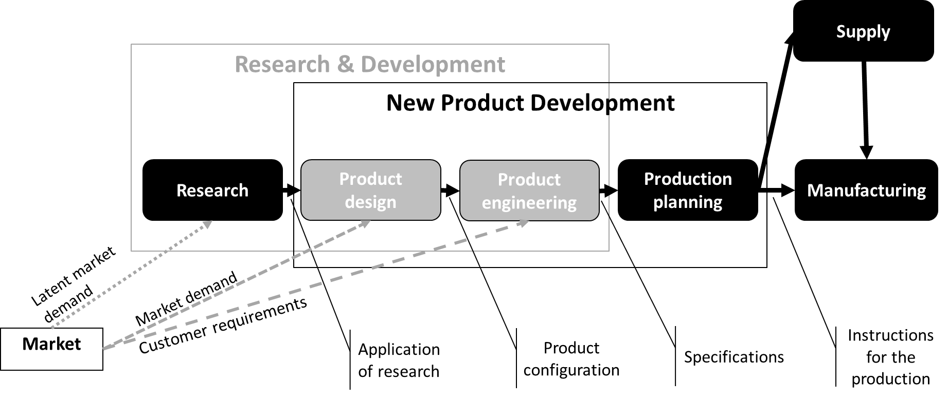
Figure 1. Production process. Notes: PDE boxes are depicted in grey colour.
When assessing productivity, a distinction between outputs and outcomes is due. Indeed, outputs measure what is produced/provided in terms of units, whereas outcomes consider the inherent value of these units. OECD [17] defines outputs as “The products, capital goods and services which result from a development intervention” (p. 28) and outcomes as “The likely or achieved short-term and medium-term effects of an intervention’s outputs” (p. 28). Managers could be interested in productivity measures that consider both PDE outputs (e.g., the number of projects delivered) and PDE outcomes (e.g., the number of projects that met the customers’ expectations and won their appreciation). De Kruijf & de Vries [18] summarised several key differences between outputs and outcomes: the former being “system-oriented” and having “immediate effects” as opposed to the latter being “context-oriented” and having “intermediated and long-term effects” (i.e., in the previous example, the number of delivered projects depend on the internal system at a certain moment, whereas their appreciation partly depends on external stakeholders and can have significant lag time, as well as a long-term impact on customer loyalty). Furthermore, PDE activities may result in entirely new products or engineering changes, whose underlying processes may be complex and inefficient [19].

Product design and engineering productivity
The assessment of firm productivity comprises a major stream of managerial literature. Industrial productivity is typically defined as the ratio between outputs and the resources needed by the manufacturing transformation process to obtain them [20]. Productivity in manufacturing depends on the “constant quality assumption,” which is normally taken for granted and undertakes that the quality of the outputs is constant [21]. Industrial productivity is an immediate reference for PDE productivity since it conceptually shares two components: the use of resources and value creation [11], [22].
A remarkable contribution to PDE productivity was published in 1998, titled “The design productivity debate,” edited by Duffy. The book presents the deliberations of the First International Engineering Design Debate. According to Duffy, the debate ended with a fair agreement that productivity depends on efficiency and effectiveness. The former is defined as the benefits of the design (both in terms of the value of the technical features and lead-time of the product) on the costs (capital, labour, and overheads). Effectiveness is defined more vaguely as a measure of the achievement of the desired outcome. A definition for productivity is also submitted: “The efficiency of production of a design solution, within a business context, that is effective to the overall requirements” [23, p. 3], as well as suitable generic measures, such as the capability to meet the demands/needs; the costs; the person-hours; the fulfilment of technical requirements; the need for subsequent lifecycle phases; the reuse of knowledge; the value (if sub-contracted); and the time.
Even though many methods have been proposed in the literature to improve PDE productivity for a review, see [5], their actual impact “remains unconfirmed, because results of empirical testing are hardly available” (p. 479). Therefore, the lack of productivity indicators impedes assessing the methods recommended to improve it.
An explanation for such a lack was offered by Busby and Williamson [6]. They observed that outcome variables for PDE activities are challenging to measure since there is no definite “stopping rule”, which is needed to develop unambiguous measures. Indeed, outcomes may be influenced by other phases of the NPD process and by different organisational units or be measured long after the PDE activities have been completed. Similarly, the key difficulties in defining PDE productivity indicators were summarised by Cantamessa as follows: “the problem is to identify which should be considered as outputs and inputs of the design activity in an industrial company, and to define their quantity and quality. This may not be considered an easy task because of the apparently inextricable relationships between the technological, methodological, managerial, economic and social factors which are related to engineering activities” [7, p. 14].
Dekkers et al. [11] described productivity in PDE considering the delivery of products versus the costs (the former considered a bundle of quality, lead-time, and flexibility). However, theirs remained a theoretical argument that they did not operationalise in the article.

Productivity of New Product Development, Research and Development, and Services Activities
To approach the challenge of defining PDE productivity indicators, we performed an integrative review of previous studies on productivity in (i) NPD and (ii) research and development, whose intersection ideally defines PDE (see Figure 1). Furthermore, since a unit providing PDE activities offers a service to internal and external customers (i.e., it develops designs, projects and requirements delivered to the production unit or directly to the company’s customer), we investigated productivity in services too (iii).
Regarding NPD productivity, Loch et al. [24] published one of the first studies proposing three measures: personnel intensity (number of development employees on the total number of employees), expense intensity (development expense on sales), and new product productivity (number of new products on number of R&D employees). While personnel intensity does not appear as a typical productivity measure (output on input, as defined in subsection 2.2), the second and the third measures paved the ground for the subsequent studies. Indeed, they incorporate inputs (development expense and number of R&D employees), one output (number of new products) and one outcome (sales) that shaped other measures in both NPD and R&D productivity. Harmancioglu et al. [25] defined NPD productivity as the “degree of product innovativeness” on the time dedicated to NPD (from ideation to commercialisation). Cooper and Edgett [2] defined NPD productivity as sales from new products on R&D spending. More recently, Iazzolino and Laise [26] renounced to measure technical productivity and measured the economic productivity of NPD knowledge workers as the ratio between the product’s value-added and the cost of the project team. Finally, Cooper and Sommer [4] emphasised how the software industry’s agile development process has been borrowed by manufacturing firms to improve NPD productivity but did not specify how productivity was assessed. A recent review [27] emphasised the emerging role of customers and diverse knowledge sources in NPD processes and success and discussed – citing Cooper and Edgett’s study (2008) - the impact that new NPD processes can have on productivity.
Several insights can be drawn from these studies. First, they use outputs that may not be easily extended to PDE since they partly depend on other organisational units’ activities. Indeed, the number of new products introduced depends on the research activities that have brought to their conceptualisation and the choice to industrialise them after the engineering phase. Similarly, the novelty of a product depends on the performed research, while the sales from new products depend on the chosen marketing mix. Another issue is posed by the inputs chosen by the mentioned studies. Indeed, only a relatively small share of the total number of employees is usually involved in PDE activities making such an input too generic to be useful. In contrast, the number of R&D employees or the R&D expenses would only partially describe PDE activities.
Regarding R&D productivity, Pappas & Remer [28] claimed that the different stages of R&D (basic research, exploratory research, applied research, development, and product improvement) require different approaches. In their early study, the authors observed that the product development and improvement phases could leverage quantitative measures better than the others. Therefore, when choosing R&D productivity indicators, a key aspect is to identify the goal of the R&D activity and the purpose of the productivity measurement system [28]. Possible goals include R&D financial performance, the ability to develop and deliver new products, the capability to manage the projects, the effectiveness of R&D communication with the related business units, and customer satisfaction. A few years later, on the same topic, Brown and Svenson [29] remarked the importance of focusing on external measurements rather than internal ones only. They suggested focusing on outcomes and outputs (quantity, quality, and cost) rather than on behaviour; considering valuable accomplishments only; collecting a few comprehensive indicators (6-8) rather than many individual measures; using objective measures; and separating the assessment of “Research” from that of “Development.” Subsequently, Brown and Gobeli [30] offered an overview of the most popular R&D productivity indicators. More recently, Paul et al. [31] considered R&D productivity in terms of R&D efficiency (the extent to which the R&D activity produces certain outputs from given inputs) and R&D effectiveness (the extent to which the outputs have certain desirable characteristics that create value to the stakeholders). Another recent approach, known as research quotient [32], [33], adapted the total factor productivity formulations to include new variables such as R&D investments, but have revenues as an outcome and consider other non-research related inputs such as advertising investments.
The literature on R&D productivity offers several insights that apply to PDE productivity: (i) the need to describe the purpose of the PDE activity and the productivity assessment process, (ii) the need to use a dashboard of indicators instead of a single indicator, (iii) the opportunity to consider outputs and outcomes in such a dashboard.
Finally, regarding productivity in services, Grönroos & Ojasalo [34] emphasised that - unlike industrial productivity - the constant quality assumption does not apply to most service processes since productivity and the perceived quality of the services are inseparable phenomena. Therefore, an assessment of productivity cannot be based solely on process efficiency and output quantity but also needs to consider its effectiveness [35]. However, productivity in services is typically assessed in terms of labour productivity [34], the ratio between an output/outcome (e.g., sales, gross value added, profit, gross output) and labour intensity (e.g., the number of employees or the number of worked hours). Parasuraman [36] thoroughly discussed the importance of considering service quality and service productivity jointly and of adapting conventional productivity concepts to the peculiarities of service design. Lo and Chiu [37] resorted to Data Envelopment Analysis to assess service design productivity, using costs and working hours as inputs and customer satisfaction as the output. More recently, Laitinen et al. [38] analysed public service productivity in terms of efficiency and effectiveness, considering both quantitative data and qualitative data, including emotional labour input and users’ positive experience with the service. On the whole, as Djellal and Gallouj [39] posed, it is difficult to identify the outputs of service activities and distinguish such outputs from the production factors that contributed to its realisation. The authors also distinguish between outcomes (e.g., sales) and outputs (e.g., the number of served customers).
The studies on service productivity confirm (i) the difficulty of identifying standardised outputs, (ii) the need to discard the constant quality assumption and to consider the quality of the provided services, (iii) the opportunity to consider outputs and outcomes to assess productivity.
Figure 2 summarises how the insights drawn from the three streams of literature.
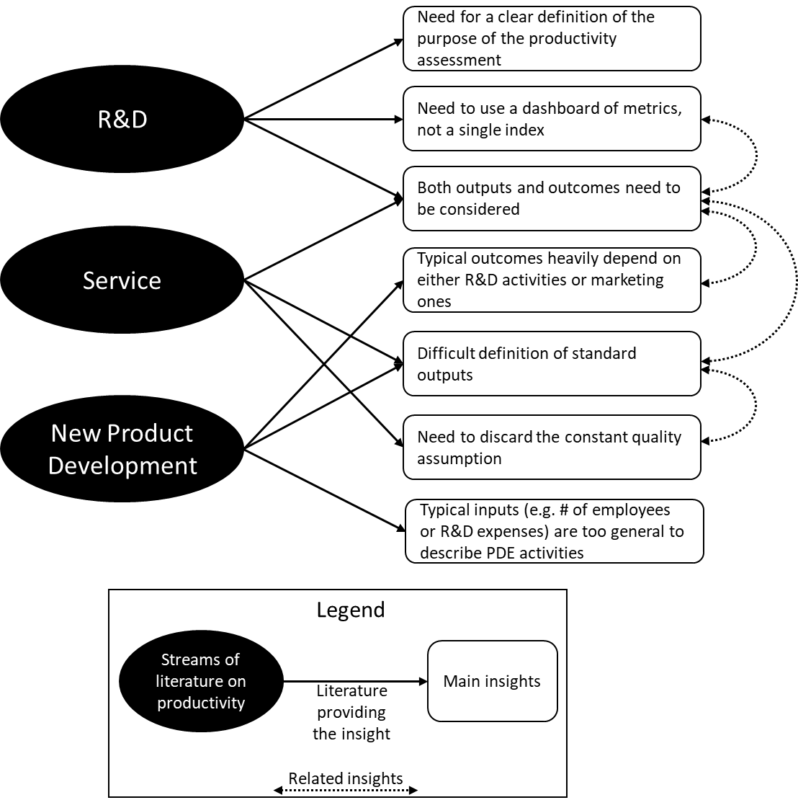
Figure 2. Main insights from the three streams of the literature on productivity. Notes: dotted lines describe conceptually close insights.

A dashboard for product design and engineering productivity
Leveraging the literature described in the theoretical background, we advance that PDE productivity should be assessed using a set of indicators capable of addressing the multiple challenges discussed before: (i) identify clear and standardised outputs; (ii) identify inputs that reflect the actual ones used during the PDE activities; (iii) consider both efficiency and effectiveness; (iv) use a set of productivity indicators (v) consider both outputs and outcomes. Accordingly, we propose the following process for a firm willing to assess its PDE productivity.

Setting a goal
As suggested in the literature, productivity indicators should be defined after a clear goal has been identified. In most circumstances, such a goal will be to assess how the resources (people, processes, tools, budget) available to PDE organisational units are used to achieve the outputs and outcomes defined by the management or the customer. A longitudinal analysis of productivity indicators could be used to assess the impact of a revision in the engineering or organisational processes, a change in the tools available to the PDE human resources, or to relate the productivity indicators with other performance measures (e.g., customer satisfaction, sales, turnover rate of human resources). The indicators can be adapted according to the managers’ priorities and the firm’s industry. Managers should also account for the multi-domain (people, product, and process) nature of PDE, especially for complex product design and development [40].

Inputs and resources
Systems theory differentiates between input and resource. The former represents a flowing element while the latter constitutes human work and equipment [41]. PDE activities typically leverage resources – and especially human capital – while other inputs have a neglectable impact. However, since productivity is typically defined as the inputs used to obtain certain outputs, we use the term inputs instead of differentiating between inputs and resources, giving “input” a broader meaning than systems theory.
Typical inputs used to assess productivity include the number of employees involved in the activities under investigation. However, such a measure may not assess PDE productivity properly if the employees involved in PDE activities also contribute upstream (to the research activities) or downstream (to the subsequent industrialisation of the product). Better input measures would be the number of hours dedicated by the human resources to the relevant PDE activities. Such measures could be drawn from the enterprise resource planning (ERP) dataset in those firms that require the employees to fill in a detailed timesheet. In addition, since PDE activities can be performed with other stakeholders, such as customers and suppliers, some indicators could also consider their contribution.
PDE activities are influenced by many important factors such as human resources’ education and training, creativity, autonomy, availability of ICT tools, usage of open innovation, in-licensing of technologies that could be integrated into new products, crowdsourcing of ideas and technologies, etc. Such factors can moderate the impact of the inputs mentioned above on PDE activities’ outputs. However, in some circumstances, firms may consider some of them as inputs if their role is considered as important (or even more important) than straightforward measures such as the time spent on a project.

Outputs and outcomes
PDE units are involved in multiple activities that can be described through output measures. In most circumstances, the design activities will be defined by the number of CAx models (e.g., CAx stands for Computer-Aided and “x” means: software, electronics, materials, mechanics, and systems released), the engineering activities will return requirements and technical documents. In certain industries, PDE units will also be involved in writing lines of code or electronic equipment development. Such outputs could be eligible as numerators of as many productivity indicators. The i-th output-oriented productivity indicator for the t-th period (e.g., month, semester, year) would be defined as Equation (1):

$OutputProductivity_{it}=\frac{PDE Output_{it}}{PDE Input_{it}}$ (1)

Nevertheless, in line with previous studies on NPD productivity, R&D productivity, and service productivity, the management wants to measure how such outputs become outcomes that create value (i.e., that have short- and medium-term positive impact on the company). As mentioned before, typical NPD outcomes such as annual revenues on new products, innovativeness of the new products, number of patents, and general customer satisfaction would not be adequate outcome measures for PDE productivity since other organisational units heavily influence them (such as R&D, marketing, production, and logistics units). Therefore, we suggest using outcome measures strictly related to the PDE outputs and consider their perceived quality. A technically correct PDE output (e.g., a design document) may not suffice to satisfy the customer (e.g., due to misalignments regarding the agreed requisites, the unsatisfactory appearance of the project, or late delivery) or regulators. Hence, outputs need to be qualified by leveraging the feedback from external subjects. Doing so, the output becomes an outcome since it is “context-oriented” and describes the medium-term effect of the outputs generated by the PDE activities on the company (e.g., in terms of customer retention, time and money spent on reworking, damage to the company’s image). For instance, the PDE outputs in some industries are subject to external certification, which returns a proxy of how well they were engineered. Therefore, the number of requirements for achieving such certifications (i.e., in aerospace, automotive, railway, or energy utility sectors) would be suitable outcome measures. In other circumstances, the (internal or external) customer may reject designs and requirements, possibly due to production errors or deviation from standards. The extent to which the outputs are perceived as appropriate by the customer is another possible outcome measure. Hence, the j-th outcome-oriented productivity indicator would be defined as Equation (2), which splits productivity in efficiency and effectiveness, as done in the traditional definition of productivity and suggested in earlier PDE productivity studies:

$OutcomeProductivity_{jt}=PDE Efficiency_{jt}*PDE Effectiveness_{jt}$ (2)
with
$PDE Efficiency_{jt}=\frac{PDE Output_{jt}}{PDE Input_{jt}}$ (3)
$PDE Effectiveness_{jt}=\frac{Acceptable PDE Output_{jt}}{PDE Output_{jt}}$ (4)

Based on the goals set by the management, the dashboard can be completed with measures considering the PDE unit’s capability to meet their forecasted completion dates (Brown & Gobeli, 1992). Such a capability is important to guarantee that the production planning does not suffer from unexpected delays and mitigates the risk of not meeting contractually agreed deadlines (e.g., milestones). This risk can be particularly high for complex NPD projects due to inadequate planning techniques [42]. Similarly, budgeted costs could be compared with the actual ones.
Unlike traditional productivity, where standard outputs (e.g., number of products) are delivered at a reasonably constant rate (except for eventual seasonality), PDE outputs may be delivered at a more discontinuous rate, possibly depending on the degree of novelty of the ongoing projects. Indeed, depending on the industry and nature of a project, completion can take weeks, months, or even years. There might be periods when PDE activities are on hold and others when such activities are frenzied. Such discontinuity factors could be controlled using reasonably long observation periods (e.g., trimesters or longer) or multiple-month running average values with an N-period time horizon. N will need to be adjusted according to the firm’s business (e.g., firms working on commissioned orders may have PDE activities that last many months on average). Another option would be to assess which specific inputs have been dedicated to a certain project and assess productivity accordingly, regardless of lag time.

An Exemplary Implementation of the Product Design and Engineering Productivity indicators Dashboard
This section describes an exemplary implementation of the dashboard in Leonardo. Subsection 4.1 presents the firm where the dashboard was implemented, subsection 4.2 describes the implementation process, and subsection 4.3 shows the results.

The company
We implemented a dashboard of productivity indicators in Leonardo, an Aerospace & Defence multinational high-tech firm with 180 offices, headquarters in Italy, and over 45’000 employees in 12 countries. Up to 2018, the company consisted of seven divisions (Helicopters; Aircraft; Aerostructures; Airborne and Space Systems; Land & Naval Defence Electronics; Defence Systems; Security & Information Systems). For PDE activities monitoring, Leonardo also considers one of its most important controlled companies as a division. Each division has a specific business portfolio, a market, and full accountability over its results. Therefore, the engineering units of each division operate in different markets and face different technological challenges. Nonetheless, suitable metrics need to be implemented to compare their productivity, enabling them to improve the engineering processes.
Leonardo is ideal for an illustrative implementation of our approach to measuring PDE productivity for four key reasons:
- the company comprises divisions whose activities include many different engineering disciplines;
- the management has a strong interest in the quantitative assessment of performance and is keen to have easy-to-implement, straightforward and scalable measures that could be used transversally to offer a comprehensive overview of the heterogeneous PDE units;
- PDE-related data are available since the second half of 2016, thanks to the widespread and detailed use of the ERP system and the Product Life Cycle Management (PLM) system to account for working hours and used resources;
- the company had defined a set of PDE KPIs, grouped in different categories, to be measured by all divisions. Each KPI has been thoroughly described in fact sheets (e.g., see Figure 3) to guarantee a standard data collection and is gathered monthly.
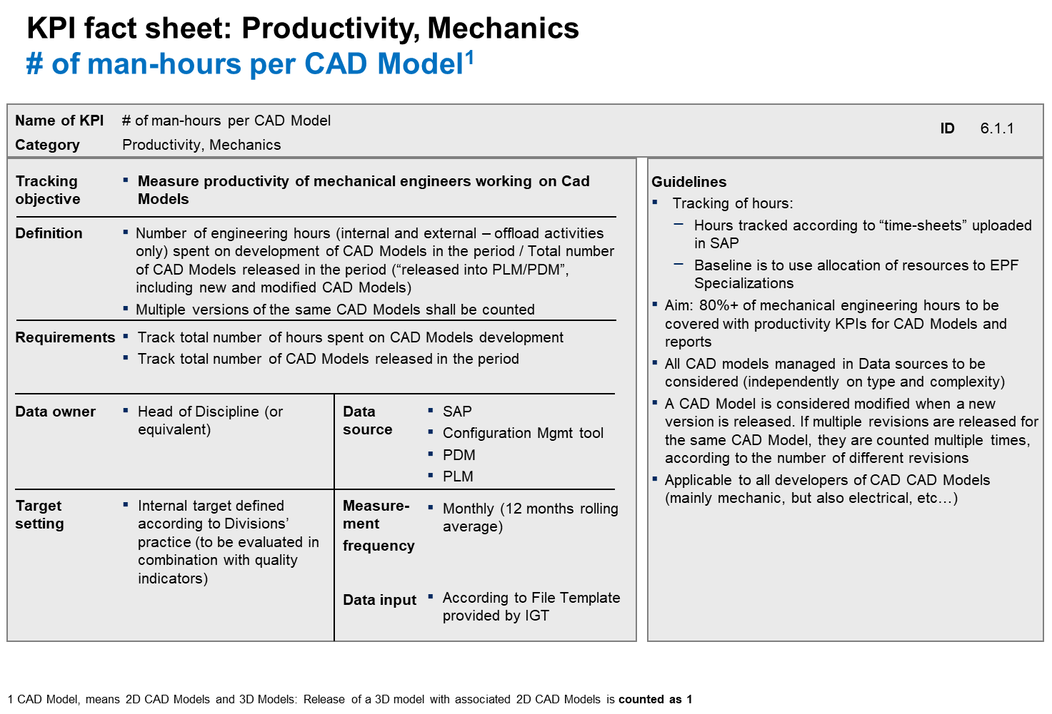
Figure 3 Example of KPI fact sheet

Methodology: The implementation of the dashboard
Leonardo's Head of Corporate Engineering Governance and two of his senior Engineering team collaborators promoted the implementation of the approach we presented in Section 3. In this task, they collaborated with three senior researchers. Hereafter, we will refer jointly to the two groups as the research team. Hence, the implementation of the dashboard followed a participatory action research approach [15], where researchers and corporate participants collaborated to co-construct the knowledge needed by the company.
As a first step, the manager identified a set of three goals, including 1. setting up a dashboard of indicators to measure the impact of organisational changes on PDE productivity; 2. identifying internal thresholds of productivity and quality that could serve to define division-specific goals; 3. compare productivity results with external industry benchmarks. Starting from this three-fold goal, the research team defined five output-oriented and four outcome-oriented productivity indicators (Table 1).
The definition of such indicators started from a larger set of candidates (over 200 suitable input and output metrics, drawn from Leonardo’s ERP and PLM systems). First, the research team went through each of them, selecting the most promising ones according to the rationale described in subsections 3.2 and 3.3 (i.e., inputs that are likely to be key determinants of the outputs/outcomes that describe the desired result of PDE activities the best). Next, the research team narrowed down the initial set of metrics to avoid unnecessary duplications (e.g., indicators that measured two strongly correlated outputs) and inaccuracies (e.g., indicators for which raw data were considered unreliable). Examples of discarded metrics include new product ideas gathered (which depends heavily on the innovation posture of the company), software problem reports (which would apply to a subset of the divisions) and customer-non compliances (due to the lack of data dynamics to be evaluated). Finally, where necessary, the research team invited the divisions to complete missing data or to produce additional metrics based on their archives and complementary datasets (e.g., the data needed to define the novelty variable, described in the next subsection, were not available in the ERP or PLM systems for most divisions).
The output-oriented measures cover the five typical PDE activities performed in most divisions of Leonardo: electronic systems development (P₁), software development (P₂), system requirement development (P₃), test development and execution (P₄), and CAD design (P₅).
The outcome-oriented measures account for both the output per input rate of typical PDE activities (efficiency) and the extent to which such outputs are in line with acceptable standards (effectiveness). Among them, we defined P₆ as the number of technical documents (such as specifications, design, plans, and interface documents) released by the PDE units on the total number of engineering hours, excluding those that are dedicated CAD models (efficiency).

Output Productivity indicator | Description | Outcome Productivity indicator | Description
Interconnections in electronic systems (IES) | $$P_{1}=\frac{\#Hundreds of IES}{\#hours of IES development}$$ | Technical documents (TD) | $$P_{6}=TD efficiency*TD effectiveness$$  $TD effic.=\frac{\# TD released}{\#engineering hours on TD}$  $TD effec.=\frac{\# TD released-TD modified for errors}{\# TD released}$
Logical lines of code (LLOC) | $$P_{2}=\frac{\# Thousands of LLOC}{\#hours on software development}$$ | Technical documents (TD)
System requirements (SR) | $$P_{3}=\frac{\# developed SR}{\# hours on SR development}$$ | Technical documents (TD)
Test development | $$P_{4}=\frac{\# Tests carried out}{\# hours on test development}$$ | Technical documents (TD)
CAD models | $$P_{5}=\frac{\# CAD models released }{\# hours for CAD models}$$ | Mechanical documents | $$P_{7}=CAD efficiency*CAD effectiveness$$  $CAD effic.=\frac{\# CAD models released }{\#engineering hours for CAD models}$  $CAD effec.=\frac{\# CAD models not reworked for errors}{\# CAD models released}$
 |  | On-time (milestones) | $$P_{8}=\frac{\# PDE milestones achieved on time}{\#PDE forecasted milestones}$$
 |  | On cost (budget) | $$P_{9}=\frac{Budgeted cost of work performed}{Actual cost of work performed}$$
Table 1: Exemplary dashboard of the productivity indicators. Note: # stands for ‘number of.’

We excluded the technical documents that were revised due to a found non-conformity by the customer (effectiveness).
P₆ provides an aggregate outcome that corresponds to the first four output productivity indicators. P₇ describes how many CAD models are released on the hours of design (efficiency) and how many of such released CAD models are not reworked models due to an error discovered by the customer (effectiveness). Finally, P₈ and P₉ describe the extent to which the PDE unit completes its milestones on time and on budget, respectively. Meeting milestones and budget is particularly important in Leonardo, which has been implementing waste assessment and root cause analysis approaches to contain time losses since 2016-17.
While P₆ and P₇ are outcomes with an external focus (a customer needs to confirm that the output meets the agreed requirements), P₈ and P₉ have an internal focus since they represent the PDE unit’s capability to comply with the plans.
We applied the productivity indicators to all the divisions of Leonardo. For the sake of brevity, we present in this paper the results achieved by the six larger PDE divisions, which comprise almost 8’000 employees. The productivity indicators have been calculated in two different moments, depending on the availability of raw data:
- Phase 1 indicators relative to the years 2017 and 2018,
- Phase 2 indicators relative to the year 2019.
During 2019, Leonardo PDE activities underwent four major changes:
- A re-organisation of some divisions, due to a more product-focused approach, to integrate the different engineering disciplines better (for the sake of the research objective, we analysed data according to the “old” organisation).
- The introduction of a new operational planning system in two divisions (D4 and D5) in 2019, which will be completed in 2020-2021 in all the other divisions.
- The deployment of an integrated PLM suite in divisions D4 and D5, which imported the PDE configurations from a set of five different PLMs.
- The deployment of a new PLM platform in division D3 allowed digitalising some legacy products' configurations. Furthermore, it enabled the collection of more PDE data than in previous years.
These four major initiatives had different trigger decisions. Still, they have in common the objective to improve the firm's overall performance - and PDE in particular - and improve the company’s performance itself, which can be summarised by the P₈ and P₉ indicators trends.

Results
The data displayed in Table 2 show the aggregate productivity indicators for the years 2017, 2018, and 2019 of six divisions. We also introduced the control variable novelty, defined as the ratio between the PDE costs for developing new products and total PDE costs (including those costs caused by the modifications of previously launched products). Figure 3 shows the trends and per cent differences, while Table 3 (in the appendix) shows Pearson’s correlation indexes. Hereafter, we discuss the main insights drawn from the productivity indicators analysis, including some of the most remarkable differences between 2017 and 2019.
P₁ [Interconnections in electronics] is the only productivity indicator that improved for most divisions, in line with the company’s expectations due to the introduction of new computer-aided development systems. Such systems increased the number of automated processes (model-based design and automatic code generation using commercial IP modules and libraries) and improved the management of technical documents. Of particular interest is the +478% achieved by D7, mainly due to a massive increase in output, and the results of D6, which largely outperformed the other divisions.
P₂ [Logical lines of code] decreased or maintained stable its level in most divisions. D4, whose software programming activity is relatively less complex than other divisions, consistently had the highest productivity indicator level.
P₃ [System requirements] strongly increased for D2 and D6, which also experienced increases in novelty. This link – also confirmed by a 0.45 Pearson correlation - suggests that the PDE units perform system requirements activities more productively for novel products. In both cases, the improvement of the indicator was caused by a remarkable increase in the outputs in the three years (+436% for D2, + 73% for D6), against a lower increase of the hours of work (+119% for D2, +39% for D6). Leonardo has analysed the processes and tools used to support the system requirements management process in D2 and D6 since they outperformed the other divisions, intending to transfer to the other divisions the best practices. According to the analysis, some of the improvements were due to new management tools for technical documents and requirements that supported partial automation of the processes and reduced the time spent by middle managers (and the related cost) to review and authorise the intermediate development artefacts. The introduction of the “Digital Twinning” concept encompassed the evolution from a mix of 2D-3D product representation to a fully digital version of the physical product (including physical, chemical, mechanical, ergonomics, fluid dynamics and aeroelastic characteristics) and enabled such management tools. The digital models flow from engineers through the product lifecycle management environment, to manufacturing, to the service and support activities with fewer intermediate steps, no data format changes, prompt updates of the digital version when the product is improved, and complete coherence of the configurations (which are essential for the aerospace safety and airworthiness certifications). From a managerial perspective, digital twinning allowed keeping track of all the technical documents’ authorization process and their adherence to the customers’ requirements.
P₄ [Test development] worsened in most divisions, except D3 and D7. In the worst cases (D4 and D6), the decrease exceeded -80%, caused by a massive reduction of the released tests despite increased hours dedicated to their development. Such a change has been triggered by improving the design quality and avoiding the late discovery of issues. An outlier, characterised by the indicator of D3 in 2019, is due to three major test campaigns with repeated testing of the same outputs. In the early stage of development, these campaigns implied using digital mock-ups of the systems (real systems under development had “digital twins”). Hence, the tests were processed by simulating the expected behaviours more rapidly.
P₅ [CAD models] fluctuated for most divisions, which ended in 2019 with worse figures than in 2017. In three cases, D2, D3, and D7, the decrease is around -30%. However, an analysis of the indicator components shows that the causes for such a decrease are different (e.g., for D2, the number of CAD models decreased less than the decrease in time dedicated to the activity, while for D3, the number of CAD models increased but the corresponding engineering hours increased much more). Those contradictory results have been justified by the learning curve needed for mechanical engineers to operate the new digital technologies introduced in such areas (e.g., digital CAD tools allowed new 3D simulations that absorbed time, negatively impacting this indicator but greatly improving the subsequent mechanical processing).
P₆ [Technical documents] has been stable in absolute value and decreasing in relative terms for most divisions. This result suggests that a process innovation should be undertaken to improve all divisions’ productivity transversally. Leonardo is foreseeing improvements for this indicator in 2020 and 2021, thanks to the deployment of digitisation in many PDE processes, which will also support process automation by using state-of-art PLM platforms.
P₇ [Mechanical documents], as expectable, shows a similar pattern to P₅. An exception is D4, which improved P₅ and improved P₇ even more, showing a parallel increase in efficiency and effectiveness. This result attracted the management's attention to defining a best practice for the other divisions concerning new technology’s introduction, the related change management for the engineering activities, and the positive effects on later manufacturing activities. Indeed, the experience of divisions such as D4 induced the management to adopt a uniform PLM approach instead of the variety of tools used before. Such choice will enable data-driven exploitation across different PDE projects of each division and a smoother process from PDE to manufacturing. The company embraced this change defining framework agreements with the main IT vendors to define technology acquisition roadmaps.
P₈ [Milestones] improved for most divisions. It is lower for the divisions with higher levels of novelty (Pearson’s correlation index -0.59), indicating the difficulties faced in meeting the temporal milestones when developing new products. However, P₈ productivity improved for D6 (+36%) despite a +15% increase in novelty. This result was achieved thanks to an increase in the number of established milestones (+36%), corresponding to an even larger increase in the number of met milestones (+54%). The result suggests that a moderate increase in milestones granularity could be a potential best practice applicable to other divisions willing to improve their level of P_{8.}
P₉ [Budget] is at high levels for most divisions. Best practices for this productivity indicator could be drawn from D6 and D7, which nearly perfectly met the budget in the three years and even exceeded the expectations in 2019 (for D7). Notably, D5 experienced a major change in the information system in 2018 that hampered its functioning, while 2019 allowed it to make up for the losses.

Year | Division | Output productivity indicators |  |  |  |  | Outcome productivity indicators |  |  |  | Novelty
Year | Division | P₁ | P₂ | P₃ | P₄ | P₅ | P₆ | P₇ | P₈ | P₉ | Novelty
Year | Division | Interconnections in electronic systems (IES) | Logical lines of code (LLOC) | System requirements (SR) | Test development (TD) | CAD models | Technical documents | Mechanical documents | On-time (milestones) | On cost (budget) | Cost for novel products on the total cost
2017 | D2 | † | 0,003 | 0,195 | 1,066 | 0,043 | 0,007 | 0,039 | 0,963 | 0.970 | 0,21
2018 | D2 | † | 0,002 | 0,519 | 0,888 | 0,043 | 0,007 | 0,030 | 0,918 | 0.929 | 0,27
2019 | D2 | † | 0,006 | 0,477 | 0,871 | 0,032 | 0,009 | na | 0,896 | 0.960 | 0,24
2017 | D3 | † | 0,015 | 0,293 | 1,590 | 0,045 | 0,006 | 0,039 | 0,768 | 0.910 | 0,22
2018 | D3 | † | 0,006 | 0,040 | 0,796 | 0,057 | 0,007 | 0,051 | 0,766 | 0.904 | 0,27
2019 | D3 | † | 0,007 | 0,144 | 2,032 | 0,030 | 0,004 | 0,028 | 0,992 | 0.813 | 0,32
2017 | D4 | 0,041 | 0,027 | 0,226 | 0,346 | 0,071 | 0,003 | 0,064 | 0,686 | 0.942 | 0,78
2018 | D4 | 0,057 | 0,027 | 0,056 | 0,084 | 0,150 | 0,003 | 0,134 | 0,688 | 0.847 | 0,67
2019 | D4 | 0,064 | 0,026 | 0,040 | 0,038 | 0,080 | 0,001 | 0,077 | 0,661 | 0.914 | 0,80
2017 | D5 | 0,125 | 0,010 | 0,016 | 0,016 | †† | 0,01 | †† | 0,621 | 0.856 | 0,20
2018 | D5 | 0,244 | 0,009 | 0,006 | 0,007 | †† | 0,01 | †† | 0,661 | 0.510 | 0,25
2019 | D5 | 0,118 | 0,011 | 0,006 | 0,007 | †† | 0,007 | †† | 0,703 | 0.864 | 0,23
2017 | D6 | 0,595 | 0,002* | 0,531 | 1,086 | 0,039 | 0,007 | 0,031 | 0,440 | 0.940 | 0,74
2018 | D6 | 0,870 | 0,001 | 0,638 | 0,140 | 0,044 | 0,008 | 0,035 | 0,595 | 0.972 | 0,93
2019 | D6 | 0,864 | 0,002 | 0,661 | 0,155 | 0,044 | na | 0,035 | 0,597 | 0.974 | 0,85
2017 | D7 | 0,023 | 0,020 | 0,054 | 0,411 | 0,156 | 0,002 | 0,152 | 0,951 | 0.977 | 0,38
2018 | D7 | 0,009 | 0,011 | 0,048 | 0,271 | 0,078 | 0,001 | 0,076 | 0,921 | 0.940 | 0,39
2019 | D7 | 0,133 | 0,011 | 0,047 | 0,550 | 0,109 | na | 0,101 | 0,928 | 1.044 | 0,40
Table 2: Productivity indicators for the three years 2017-2019. Notes: green font, the division has the largest productivity indicator in the year; red font, the division has the smaller productivity indicator in the year; †, no electronic PDE activities in the division; ††, mechanical PDE activities not meaningful in the division; * value corrected for the presence of an outlier; na, data not available.

P₈ and P₉ could also be improved through a general upskilling reached through the training programs carried out in Leonardo Academy (a specific unit under HR responsibility to deploy continuous high-level technical education for employees on engineering and manufacturing units). Such programs are also connected to the new technologies that will be developed in the next years in Leonardo. Hence, Leonardo Academy serves as an enabler for the performance improvement of almost all the PDE indicators.
The productivity indicators and the KPIs used to calculate them are presented to the top management with the visual support of tables (e.g., see Table 2) and figures (e.g., see Figure 4 and Figure 5). Based on the results outlined in Phase 1 and Phase 2, Leonardo is improving its processes and tools to support PDE activities; leverage the best practices analysed in some divisions; deploy digitisation in many PDE departments; measure the expected improvements during a possible third phase covering 2020 and 2021.

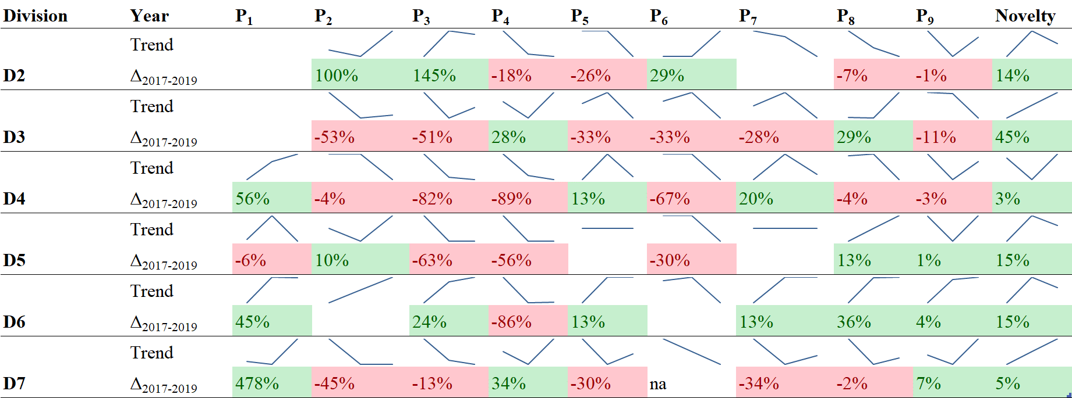
Figure 4. Intra-divisional trends of the productivity indicators and per cent difference from 2017 to 2019.
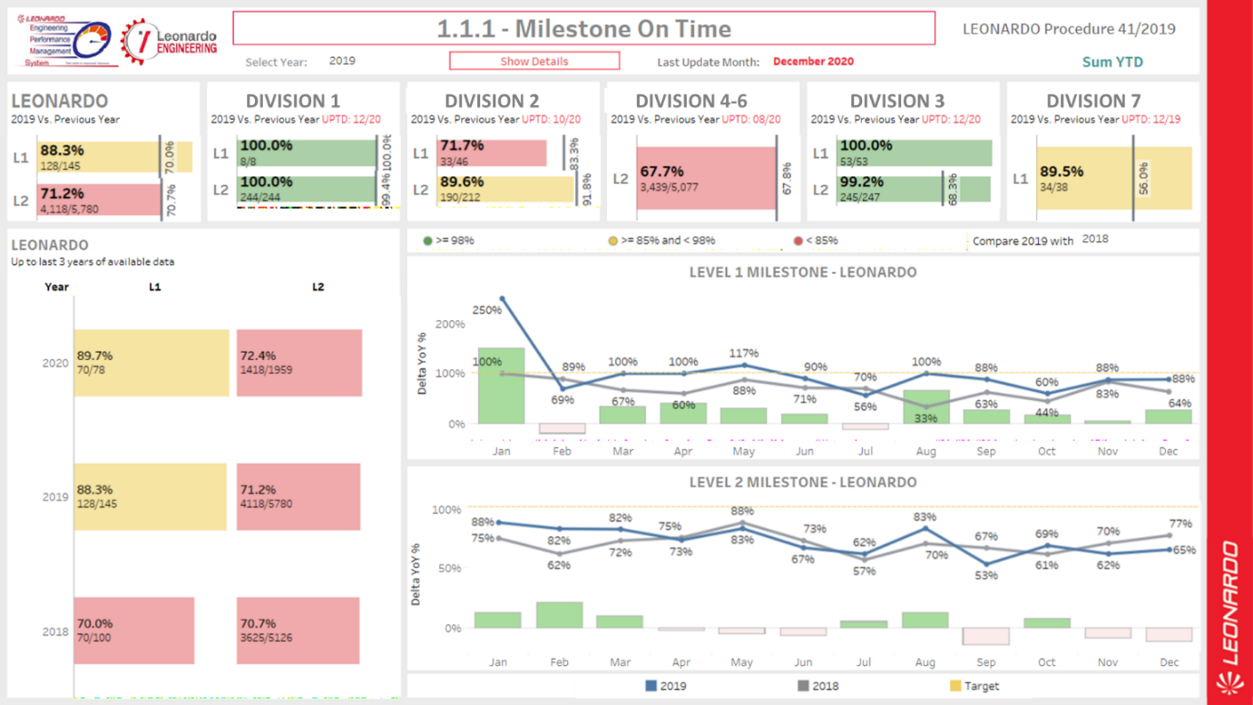
Figure 5. Visual representation of the trends of one of “Milestones on time”, the numerator of the P₈ productivity indicator.
The strategic objectives, the other internal initiatives (such as the Leonardo Industrial Plan, the CMMI certifications achieved by some Divisions, and the strategical choice of digitization implementation) and the analysis of productivity indicators brought Leonardo to define a set of initiatives. Such initiatives, called Charters, are to be developed in the 2021-2023 timeframe, whose effect will be measured with future data collection campaigns of PDE productivity indicators. Some of the Charters will have a more direct impact on PDE indicators than others. The six Charters imply a set of actions described in Table 4 (in the appendix).

Discussion
Assessing productivity is mandatory to identify strategies to improve it and motivate the divisional managers to align with the organisational plans and priorities [43]. PDE productivity is not an exception. Furthermore, since productivity can suffer from precipitous drops when projects are cancelled [44], its proper and timely assessment is critical to react rapidly.
The study has both theoretical and managerial implications that are described hereafter.

Theoretical implications
Differently from previous studies, we selected outputs and outcomes that depend on PDE activities alone, discarding those that involve other organisational units upstream (e.g., new product ideas due to the dependence by the innovation attitude of the company) or downstream (e.g., market success, which also depends on marketing, production and logistics). Such an approach allows a more thorough assessment of PDE productivity. We proposed that qualified outputs (i.e., outputs compliant with certain requisites or outputs net of those reworked due to engineering errors) represent PDE outcomes. This approach addresses the violation of the constant quality assumption typical of service activities [34]. We leveraged the literature [29] to propose that the assessment of PDE productivity cannot leverage a single indicator but rather requires a dashboard of productivity indicators that consider outputs and outcomes. Such a dashboard is essential to capture some of the variety and complexity of PDE activities.
This study can operate as a common platform for the streams of the literature offering solutions to improve PDE productivity, such as the stream on lean product development [2]. While lean production and six sigma improve productivity [45], thorough assessments of such an impact on PDE productivity are lacking. We argue that the metrics used in the dashboard should consider the logic of the approach chosen by the company. For instance, in the case of lean, the role of milestones achievement could be particularly important [46] given the impact of lean product development on reducing wastes in the process.

Managerial implications
Using a dashboard of productivity indicators offers managers a powerful tool to control the PDE activities and promptly replicate best practices and identify criticalities. We showed the potential of such a tool through the illustrative implementation of a PDE productivity dashboard in Leonardo, which allowed:
- identifying the impact of productivity of organisational practices and new tools, including new digital computer-aided development systems (e.g., P₁), management tools that supported the partial automation of some processes (e.g., P3), a different set of organisational goals to favour quality over quantity (e.g., P4), and digitisation (e.g., P5, P6, and P9);
- spotting major intra-divisional productivity falls from 2017 to 2019 (e.g., P₃, P_{4,} and P₆), which is needed to address the causes behind them;
- pinpointing best practices that could be extended to all divisions (e.g., P₅, P₈, and P₉);
- understanding the relationship between the degree of novelty of the division’s PDE activities and some productivity indicators (e.g., P₃ and P₈).
Notably, while we used yearly indicators to offer an overview of the dashboard in three years, managers can retrieve inputs and outputs/outcomes more frequently and assess them through rolling average values. In such a case, the dashboard could be adapted to present frequently updated productivity indicators, their components, and their trends in the form of visual management systems in the workplace. Such visual aids could serve a twofold purpose: assessing productivity and leading to its improvement.
Another good approach, which we could not implement in our case, would be identifying the specific inputs and outputs/outcomes of different projects or units at the aggregate level. Such an approach would allow a more detailed assessment of the activities and, hence, more accurate corrective actions.

Limitations
Our implementation of the dashboard in Leonardo has an illustrative purpose. We recognise that many organisations would need to implement major process innovations to collect the data regarding inputs, outputs, and outcomes needed to build a dashboard of productivity indicators. The cost/benefit ratio of such an implementation would depend on whether PDE activities are a major source of competitive advantage and costs for the firm.
The exemplary dashboard we used in Leonardo may not be applied tout-court to other companies since it needs a setting-up and fine-tuning process – based on the target company’s PDE activities characteristics – as described in section 3. However, a dashboard composed of PDE productivity indicators can be easily set up in any context following the process mentioned in the article.
Another limitation lies in the indicator we used to assess the divisions’ capability to plan their work and respect the deadlines, the achieved milestones. Indeed, different divisions adopt different approaches to define their milestones (e.g., few important milestones versus many step-by-step milestones) but our analysis cannot distinguish a major milestone from a minor one.

Conclusions
In this article, we addressed the challenge of estimating the productivity of the organisational units involved in PDE activities. To this aim, we leveraged three branches of the literature on productivity, including NPD, R&D, and services. We concluded that PDE productivity needs to be assessed through multiple complementary indicators considering how relevant inputs were used to develop outputs and obtain outcomes. We also offered guidelines to build such a set (dashboard) of indicators and presented an exemplary implementation in a leading multinational company.
Our exploratory study uncovered the need for more research on PDE productivity.
First, an assessment of PDE productivity should not be limited to time and cost. Instead, it should consider important PDE metrics such as product complexity and novelty, technical accomplishments embodied in the design, and quality (e.g., designs free from errors and ambiguity) [6]. Indeed, we found that several productivity indicators are (positively or negatively) correlated with the novelty of the activities performed by the divisions under investigation. Even though our indicators could consider the quality aspect by using reliably constructed outcome measures, the product complexity aspect remains challenging. Indeed, two PDE units working on different novelty degrees (e.g., one focused on developing radically new products and another focused on improving existing products) could hardly be compared. Hence, future studies should distinguish PDE outputs based on their novelty. Furthermore, they should distinguish between novel products, which require design and engineering activities that cannot adapt previously developed designs and specifications, and modified products, consisting of improvements or customisations of previously developed products. While we expect that PDE activities pertaining to novel products can improve their productivity mainly through better training of the engineers, economies of learning, and improved technologies or tools, PDE activities pertaining to improved products could also greatly benefit from process reengineering and reuse. Therefore, distinguishing between the novel and the modified products would be important to provide firms with more detailed and relevant suggestions on how to improve PDE productivity.
Second, the lag-time between PDE activities, their outputs, and the discovery of errors in them is a difficult-to-control issue. Therefore, we suggest assessing the specific inputs (e.g., number of hours) dedicated to a specific output (e.g., a CAD model revision), keeping track of its outcome (e.g., successful production versus eventual revision request due to error).
Third, a growing stream of research studies how productivity can benefit from big data [47]. Hence, as future research, we encourage studies to unveil if and how big data could assess and improve PDE productivity. Furthermore, collaboration with external organisations often enhances NPD and process innovation, as posed by the open innovation literature [48], [49]. Therefore, future research could explore how these aspects could be integrated into a PDE productivity dashboard.
Fourth, while this study offered a framework to assess PDE productivity, future research could explore the data visualization aspects that should be considered to represent the indicators in the dashboard in the most effective way.
Finally, this research focused on inputs and outputs to assess productivity, but many factors can moderate the successful conversion of the inputs into outputs. Indeed, productivity is enhanced by many factors such as autonomy and continuous learning [8], encouragement of creativity [50], voice-of-customer ideation methods and spiral development [2], open innovation [51], [52]. While these factors cannot figure as inputs in our dashboard, they may be critical in explaining the year-on-year and division-on-division differences or even comparing the firm’s productivity with other firms in the same sector. Hence, we encourage future empirical research to consider the effect of such moderating factors on PDE productivity indicators. The availability of standard productivity indicators could allow inter-organisational comparisons and large-scale empirical analysis to unveil the drivers and barriers of productivity.

Acknowledgements
The authors thank xxx, xxx, and xxx for their support in this research. The authors also wish to thank the anonymous reviewers for their insightful suggestions.

References
[1] D. J. P. Soares, J. Bastos, D. R. Gavazzo Rodrigues, J. P. G. T. Pereira, and A. J. C. Baptista, “Lean management methods in product development - a case study based on human respect with productivity focus,” Int. J. Lean Enterp. Res., vol. 1, no. 4, pp. 393–411, 2015.
[2] R. G. Cooper and S. J. Edgett, “Maximizing Productivity in Product Innovation,” Res. Manag., vol. 51, no. 2, pp. 47–58, Mar. 2008.
[3] V. Belvedere, F. Cuttaia, M. Rossi, and L. Stringhetti, “Mapping wastes in complex projects for Lean Product Development,” Int. J. Proj. Manag., vol. 37, no. 3, pp. 410–424, Apr. 2019.
[4] R. G. Cooper and A. F. Sommer, “Agile–Stage-Gate for Manufacturers,” Res. Manag., vol. 61, no. 2, pp. 17–26, Mar. 2018.
[5] J. Hinckeldeyn, R. Dekkers, and J. Kreutzfeldt, “Productivity of product design and engineering processes,” Int. J. Oper. Prod. Manag., vol. 35, no. 4, pp. 458–486, Apr. 2015.
[6] J. S. Busby and A. Williamson, “The appropriate use of performance measurement in non-production activity: The case of engineering design,” Int. J. Oper. Prod. Manag., vol. 20, no. 3, pp. 336–358, 2000.
[7] M. Cantamessa, “Investigating productivity in engineering design: a theoretical and empirical perspective,” in The Design Productivity Debate, A. H. B. Duffy, Ed. London: Springer-Verlag, 1998, pp. 13–31.
[8] P. F. Drucker, “Knowledge-Worker Productivity: The Biggest Challenge,” Calif. Manage. Rev., vol. 41, no. 2, pp. 79–94, Jan. 1999.
[9] S. Holland, K. Gaston, and J. Gomes, “Critical success factors for cross‐functional teamwork in new product development,” Int. J. Manag. Rev., vol. 2, no. 3, pp. 231–259, Sep. 2000.
[10] R. G. Cooper, S. J. Edgett, and E. J. Kleinschmidt, “Benchmarking Best NPD Practices—II,” Res. Manag., vol. 47, no. 3, pp. 50–59, May 2004.
[11] R. Dekkers, C. M. Chang, and J. Kreutzfeldt, “The interface between ‘product design and engineering’ and manufacturing: A review of the literature and empirical evidence,” Int. J. Prod. Econ., vol. 144, no. 1, pp. 316–333, Jul. 2013.
[12] J. M. H. da Costa, J. Oehmen, E. Rebentisch, and D. Nightingale, “Toward a better comprehension of Lean metrics for research and product development management,” R D Manag., vol. 44, no. 4, pp. 370–383, 2014.
[13] E. G. Salgado and R. Dekkers, “Lean Product Development: Nothing New Under the Sun?,” Int. J. Manag. Rev., vol. 20, no. 4, pp. 903–933, Oct. 2018.
[14] M. A. Cronin and E. George, “The Why and How of the Integrative Review,” Organ. Res. Methods, pp. 1–25, Jul. 2020.
[15] A. McIntyre, Participatory Action Research. Thousand Oaks, CA: Sage Publications, 2008.
[16] V. Joachim and P. Spieth, “What Does Front-End Research Build on? A Cocitation Analysis of the Intellectual Background and Potential Future Research Avenues,” IEEE Trans. Eng. Manag., vol. 67, no. 1, pp. 105–121, Feb. 2020.
[17] OECD, Glossary of Key Terms in Evaluation and Results Based Management. Paris: OECD Publications, 2010.
[18] J. A. M. de Kruijf and M. S. de Vries, “Contextualizing the trend from output to outcome measurement: the Dutch pension system,” Public Money Manag., vol. 38, no. 1, pp. 65–72, Jan. 2018.
[19] L. Maruster and A. Alblas, “Tailoring the Engineering Design Process Through Data and Process Mining,” IEEE Trans. Eng. Manag., pp. 1–15, 2020.
[20] D. Sumanth, Productivity Engineering and Management. New York, NY: McGraw-Hill, 1994.
[21] D. S. Sink, Productivity management: planning, measurement and evaluation, control and improvement. New York: Wiley, 1985.
[22] S. Tangen, “Demystifying productivity and performance,” Int. J. Product. Perform. Manag., vol. 54, no. 1, pp. 34–46, Jan. 2005.
[23] A. H. B. Duffy, Ed., The Design Productivity Debate. London: Springer-Verlag, 1998.
[24] C. Loch, L. Stein, and C. Terwiesch, “Measuring Development Performance in the Electronics Industry,” J. Prod. Innov. Manag., vol. 13, no. 1, pp. 3–20, Jan. 1996.
[25] N. Harmancioglu, R. C. McNally, R. J. Calantone, and S. S. Durmusoglu, “Your new product development (NPD) is only as good as your process: an exploratory analysis of new NPD process design and implementation,” R&D Manag., vol. 37, no. 5, pp. 399–424, Nov. 2007.
[26] G. Iazzolino and D. Laise, “Knowledge worker productivity: is it really impossible to measure it?,” Meas. Bus. Excell., vol. 22, no. 4, pp. 346–361, Nov. 2018.
[27] G. Marzi, F. Ciampi, D. Dalli, and M. Dabic, “New Product Development During the Last Ten Years: The Ongoing Debate and Future Avenues,” IEEE Trans. Eng. Manag., vol. 68, no. 1, pp. 330–344, Feb. 2021.
[28] R. A. Pappas and D. S. Remer, “Measuring R&D Productivity,” Res. Manage., vol. 28, no. 3, pp. 15–22, May 1985.
[29] M. G. Brown and R. A. Svenson, “Measuring R&D Productivity,” Res. Manag., vol. 31, no. 4, pp. 11–15, Jul. 1988.
[30] W. B. Brown and D. Gobeli, “Observations on the measurement of R&D productivity: a case study,” IEEE Trans. Eng. Manag., vol. 39, no. 4, pp. 325–331, 1992.
[31] S. M. Paul et al., “How to improve R&D productivity: the pharmaceutical industry’s grand challenge,” Nat. Rev. Drug Discov., vol. 9, no. 3, pp. 203–214, Mar. 2010.
[32] B. L. Goldense, “Improve R&D Spending and Productivity With the Research Quotient Model,” IEEE Eng. Manag. Rev., vol. 46, no. 1, pp. 29–31, Mar. 2018.
[33] A. M. Knott, How Innovation Really Works. McGraw Hill Publishers, 2017.
[34] C. Grönroos and K. Ojasalo, “Service productivity,” J. Bus. Res., vol. 57, no. 4, pp. 414–423, Apr. 2004.
[35] R. B. Chase and R. M. Haynes, “Service operations management. A field guide,” in Handbook of services marketing and management, T. A. Swartz and D. Iacobucci, Eds. Thousand Oaks, CA: SAGE Publications, 2000.
[36] A. Parasuraman, “Service productivity, quality and innovation,” Int. J. Qual. Serv. Sci., vol. 2, no. 3, pp. 277–286, Oct. 2010.
[37] H.-P. Lo and M.-C. Chiu, “A service family design and business development methodology with a home service case study,” J. Ind. Prod. Eng., vol. 31, no. 7, pp. 458–470, Oct. 2014.
[38] I. Laitinen, T. Kinder, and J. Stenvall, “Local public service productivity and performance measurement,” Int. J. Knowledge-Based Dev., vol. 9, no. 1, pp. 49–75, 2018.
[39] F. Djellal and F. Gallouj, “The productivity challenge in services: measurement and strategic perspectives,” Serv. Ind. J., vol. 33, no. 3–4, pp. 282–299, Feb. 2013.
[40] A. A. Yassine, “Managing the Development of Complex Product Systems: An Integrative Literature Review,” IEEE Trans. Eng. Manag., vol. 68, no. 6, pp. 1619–1636, Dec. 2021.
[41] R. Dekkers, Applied Systems Theory, 2nd ed. Cham, CH: Springer, 2017.
[42] S. C. M. Barbalho, M. Monteiro de Carvalho, P. M. Tavares, C. H. Llanos, and G. A. Leite, “Exploring the Relation Among Product Complexity, Team Seniority, and Project Performance as a Path for Planning New Product Development Projects: A Predictive Model Applying the System Dynamics Theory,” IEEE Trans. Eng. Manag., pp. 1–14, 2019.
[43] R. D. Banker, “Productivity Measurement and Management Control,” in The Management of Productivity and Technology in Manufacturing, Boston, MA: Springer US, 1985, pp. 239–257.
[44] L. P. Martinich, “Excellent execution in new product development: adaptability and resilience,” IEEE Eng. Manag. Rev., vol. 44, no. 3, pp. 20–22, Sep. 2016.
[45] A. D. Makwana and G. S. Patange, “A methodical literature review on application of Lean & Six Sigma in various industries,” Aust. J. Mech. Eng., vol. 19, no. 1, pp. 107–121, Jan. 2021.
[46] B. Haque and M. James-moore, “Applying lean thinking to new product introduction,” J. Eng. Des., vol. 15, no. 1, pp. 1–31, Feb. 2004.
[47] G. Elia, G. Polimeno, G. Solazzo, and G. Passiante, “A multi-dimension framework for value creation through Big Data,” Ind. Mark. Manag., vol. 90, pp. 617–632, Oct. 2020.
[48] A. Pilav-Velić and O. Marjanovic, “Integrating open innovation and business process innovation: Insights from a large-scale study on a transition economy,” Inf. Manag., vol. 53, no. 3, pp. 398–408, Apr. 2016.
[49] J. Grönlund, D. R. Sjödin, and J. Frishammar, “Open Innovation and the Stage-Gate Process: A Revised Model for New Product Development,” Calif. Manage. Rev., vol. 52, no. 3, pp. 106–131, May 2010.
[50] C. Cheng and M. Yang, “Creative process engagement and new product performance: The role of new product development speed and leadership encouragement of creativity,” J. Bus. Res., vol. 99, pp. 215–225, Jun. 2019.
[51] M. Greco, M. Grimaldi, G. Locatelli, and M. Serafini, “How does open innovation enhance productivity? An exploration in the construction ecosystem,” Technol. Forecast. Soc. Change, vol. 168, pp. 1–18, Jul. 2021.
[52] C. H. Noble, S. S. Durmusoglu, and A. Griffin, Eds., Open Innovation: New Product Development Essentials from the PDMA. Hoboken, NJ, USA: John Wiley & Sons, Inc., 2014.

Appendix
Indicator | Description | P₁ | P₂ | P₃ | P₄ | P₅ | P₆ | P₇ | P₈ | P₉
P₂ | correlation | -0.762
P₂ | p-value | 0.004
P₂ | observations | 12
P₃ | correlation | 0.933 | -0.549
P₃ | p-value | 0.000 | 0.018
P₃ | observations | 12 | 18
P₄ | correlation | 0.177 | -0.306 | 0.207
P₄ | p-value | 0.582 | 0.217 | 0.410
P₄ | observations | 12 | 18 | 18
P₅ | correlation | -0.707 | 0.687 | -0.608 | -0.520
P₅ | p-value | 0.033 | 0.005 | 0.016 | 0.047
P₅ | observations | 9 | 15 | 15 | 15
P₆ | correlation | 0.526 | -0.671 | 0.315 | 0.025 | -0.653
P₆ | p-value | 0.118 | 0.004 | 0.235 | 0.927 | 0.015
P₆ | observations | 10 | 16 | 16 | 16 | 13
P₇ | correlation | -0.742 | 0.690 | -0.631 | -0.494 | 0.995 | -0.671
P₇ | p-value | 0.022 | 0.006 | 0.016 | 0.072 | 0.000 | 0.017
P₇ | observations | 9 | 14 | 14 | 14 | 14 | 12
P₈ | correlation | -0.607 | -0.017 | -0.278 | 0.436 | 0.127 | -0.271 | 0.220
P₈ | p-value | 0.037 | 0.946 | 0.263 | 0.071 | 0.652 | 0.309 | 0.451
P₈ | observations | 12 | 18 | 18 | 18 | 15 | 16 | 14
P₉ | correlation | 0.149 | -0.056 | 0.366 | 0.133 | 0.086 | -0.336 | 0.125 | 0.199
P₉ | p-value | 0.644 | 0.826 | 0.135 | 0.599 | 0.759 | 0.203 | 0.670 | 0.429
P₉ | observations | 12 | 18 | 18 | 18 | 15 | 16 | 14 | 18
novelty | correlation | 0.576 | 0.210 | 0.446 | -0.341 | 0.101 | -0.399 | 0.009 | -0.585 | 0.276
novelty | p-value | 0.050 | 0.404 | 0.064 | 0.166 | 0.720 | 0.126 | 0.975 | 0.011 | 0.267
novelty | observations | 12 | 18 | 18 | 18 | 15 | 16 | 14 | 18 | 18
Table 3: Pearson correlation values with pairwise deletion.

Charter | Actions | PDE KPIs | Best Practices
Charter 1: Digitisation of Product Development | - Allow a flexible and agile way of working for engineers  - Standardization and consolidation of the design toolbox  - Maximize data analytics to optimize product certification and in-service availability  - Develop virtual models of products to predict their properties and behaviors | P1, P2, P3, P4, P5, P6, P7 | Technical Documents Management  Process Automation
Charter 2: People and Skills Management | - Leverage on the major internal Research and Technology initiatives to insource disruptive and new skills  - Preserve the critical resources and manage the knowledge transfer to younger people  - Define the new roles needed in Engineering Disciplines  - Insert new resources, also improving gender diversity  - Re-train a significant number of internal resources to improve their skills  - Define the competencies to be improved or inserted by 2024, also considering the aims of the European “Skills Defence Alliance” initiative | P1, P2, P3, P4, P5, P6, P7 | Leonardo Academy  Leonardo Labs
Charter 3: Revision of the Engineering Costs Structure | - Focus on the main costs recharged from Central Organizational Units to the Divisions  - Rationalization of Operating Costs of Engineering | P8, P9 | Milestones Management
Charter 4: Engineering Offload Management | - Assessment of Engineering Offload Supply Chain Performance in terms of delivery adherence and quality | P8, P9 | Milestones Management
Charter 5: Enhancement of Engineering Processes | - Engineering Process Enhancement Roadmap Implementation  - Cyber Resilience of Products and Services  - Full Compliance to REACh and other Chemicals Regulations | P1, P2, P3, P4, P5, P6, P7 | Technical Documents Management  Process Automation
Charter 6: Products Strategy Improvement | - Assessment of the “value-added” brought by Engineering, mainly in terms of contribution to Revenues and EBITA  - Reshaping of Product Portfolio Posture  - Readdressing peculiar activities in Research and Product Development | P8, P9 | Leonardo Labs
Table 4. Actions pertaining to six Charters, corresponding KPIs and best practices

