From sewage sludge to microbial protein: the role of H₂S- and CO-tolerant hydrogen-oxidizing bacteria in syngas aerobic fermentation
Vincenzo Pelagalli¹, Silvio Matassa², Marco Race¹, Michela Langone³, Stefano Papirio², Piet N. L. Lens⁴, Marco Lazzazzara⁵, Alessandro Frugis⁵, Luigi Petta⁶, Giovanni Esposito²
1Department of Civil and Mechanical Engineering, University of Cassino and Southern Lazio, Cassino, Italy
Email: vincenzo.pelagalli@unicas.it; marco.race@unicas.it
2Department of Civil, Architectural and Environmental Engineering, University of Napoli Federico II, Napoli, Italy
Email: silvio.matassa@unina.it; stefano.papirio@unina.it; gioespos@unina.it
3Laboratory Technologies for the Efficient Use and Management of Water and Wastewater, Italian National Agency for New Technologies, Energy and Sustainable Economic Development (ENEA), Rome, Italy
Email: michela.langone@enea.it
4National University of Ireland Galway, Galway, Ireland
Email: piet.lens@universityofgalway.ie
⁵Acea Elabori Spa, Rome, Italy
Email: marco.lazzazzara@aceaspa.it; alessandro.frugis@aceaspa.it
⁶Laboratory Technologies for the Efficient Use and Management of Water and Wastewater, Italian National Agency for New Technologies, Energy and Sustainable Economic Development (ENEA), Bologna, Italy
Email: luigi.petta@enea.it

Abstract
The aerobic fermentation of syngas, generated through the pyrolysis of municipal sewage sludge, for the purpose of producing value-added products like microbial protein (MP), holds the potential to open new horizons in biorefinery approaches for wastewater treatment plants. In this regard, this study aimed to investigate the capability of a mixed community of hydrogen-oxidizing bacteria (HOB) to convert a synthetic syngas with varying H₂/CO₂ ratios, along with increasing concentrations of H₂S and CO, into MP. Remarkably, no inhibition of the enriched HOB culture within H₂/CO₂ ratios ranging from 2 to 10, H₂S concentrations up to 0.4%, and CO concentrations up to 40%, was observed. Moreover, this process exhibited consistent performance over an extended period of 30 days and resulted in the production of MP containing as much as 65% protein content in biomass.

Index Terms
Aerobic syngas fermentation; biorefinery; hydrogen-oxidizing bacteria; resource recovery; sewage sludge pyrolysis; single cell protein

- Introduction
Large quantities of municipal sewage sludge (MSS) are generated globally each year, resulting in significant operational expenses for wastewater treatment plants (WWTPs) and environmental concerns [1]. Pyrolysis allows not only MSS treatment and reduction, but also transforms it into syngas, a gas mixture primarily composed of H₂, CO, and CO₂. This syngas can be further utilized to produce valuable products like microbial protein (MP) [2], a protein-rich material (up to 80% protein content by weight) obtained from microbial biomass. MP serves as an alternative protein source for both feed and food, as well as for the production of biopolymers and slow-release fertilizers [3]. Hydrogen-oxidizing bacteria (HOB) can grow on gas mixtures of H₂, O₂ and CO₂, accumulating proteins in concentrations of up to 75% by weight. This makes HOB crucial in developing a syngas-to-MP process [4]. However, MSS-derived syngas exhibits variable compositions, with H₂/CO₂ ratios ranging from 0.1 to 10.0, and may contain inhibitory gases like H₂S and CO in concentrations as high as 2000 parts per million by volume (ppmv) and 40% by volume (v/v), respectively [5–8]. The ability of HOB to ferment gases with high H₂S concentrations remains unexplored, while only a few studies have examined pure HOB cultures exposed to CO concentrations as high as 30% v/v [9]. In this study, a mixed culture of HOB was enriched, and its performance during aerobic fermentation of simulated MSS-derived syngas, with realistic H₂, CO₂, CO, and H₂S concentrations and ratios, was evaluated. During the experiments, gas consumption, biomass concentration (as volatile suspended solids (VSS)), biomass yield on chemical oxygen demand (COD) H₂ equivalents (H₂-COD), biomass productivity, and protein content in biomass, were monitored. Additionally, the microbial community evolution in the enriched HOB culture was assessed.

- Materials and methods
Active compost was employed as inoculum source for the enrichment of HOB. The enrichment was conducted in 306 mL serum bottles partially filled with 40 mL of mineral medium prepared according to [10]. A mixture of H₂/O₂/CO₂ in a 65/20/15 volumetric ratio was injected in the headspace of each bottle [11] up to an initial pressure of 1.5 bar. The enrichment was agitated at 600 rotations per minute (rpm) at a temperature of 30 °C. During the enrichment phase, the culture and gas substrate were periodically diluted and refreshed, achieving a stable growth after 5 weeks. The enriched HOB culture was then employed in two different series of batch aerobic fermentation tests, aimed to the evaluation of the effect of specific syngas compositions. In the first series of batch tests, the effects of different syngas mixtures characterized by H₂/CO₂ ratios of 2.0, 4.3, and 10.0, H₂S concentrations from 2000 to 8000 ppmv, and CO concentrations from 10 to 40 % v/v, were evaluated in short-term applications (48 h). In the second series of batch tests, a 30 days-long observation of the effects of CO concentrations of 10 and 40 % v/v, and those of a mixed condition with CO at 10% v/v and H₂S at 2000 ppmv, was conducted by refreshing the gas and liquid phase of each bottle on a 48-96 h basis.

III. Results and discussion

- Short-term batch tests
The short-term batch tests helped in screening the performances of the enriched HOB culture in the presence of variable syngas compositions. H₂/CO₂ ratios variable between 2 and 10 caused no differences in terms of biomass yield and final concentration (0.14-0.16 g VSS/g H2-COD and 0.53-0.57 g VSS/L, respectively), as well as for protein content of biomass (62-66 %VSS) and H2 consumption (83-87%). A significatively higher CO₂ consumption (90%) was observed for H₂/CO₂ = 10, enlightening a more efficient CO₂ recovery as MP from syngas with high H₂/CO₂ ratios. The addition of H₂S and CO in concentrations up to 4000 ppmv and 40 % v/v, respectively, had no significant impact on the HOB culture, revealing its remarkable resistance towards these inhibitors. No negative effect came from H2S and CO on biomass protein content as well, with values varying in the ranges of 39-56 %VSS and 53-59 %VSS in the H₂S and CO concentration tests, respectively.

- Long-term batch tests
During the long-term batch test, CO concentrations as high as 10 and 40 % v/v (conditions CO10 and CO40, respectively), and the simultaneous exposure to CO and H₂S in concentrations of 10 % v/v and 2000 ppmv, respectively (condition CO10+H₂S) (Fig. 1), had no negative influence on the process. Biomass yield on H₂ for CO40 was significatively higher with respect to the other conditions, due to H₂-limiting conditions occurring with a lower H₂ supply. The microbiological analysis of the HOB culture before and after the long-term test revealed the determinant role played by its mixed composition. CO-tolerant HOB, such as Advenella kashmirensis, Hydrogenophaga, and Xanthobacter autotrophicus, sustained the fermentation process even at CO concentration of 40% v/v, when the genus Paracoccus (the most abundant for lower CO concentrations) was inhibited. The HOB mixed culture showed a high degree of resistance to H₂S and CO as never reported before in literature for pure/axenic HOB cultures.
The results of this study suggest that mixed HOB cultures could drive aerobic syngas fermentation even by directly employing raw syngas, with stable process performances and the production of MP with remarkable protein content up to 65 %VSS. These outcomes could positively influence the costs and technical feasibility of the syngas-to-MP route applied to MSS management.
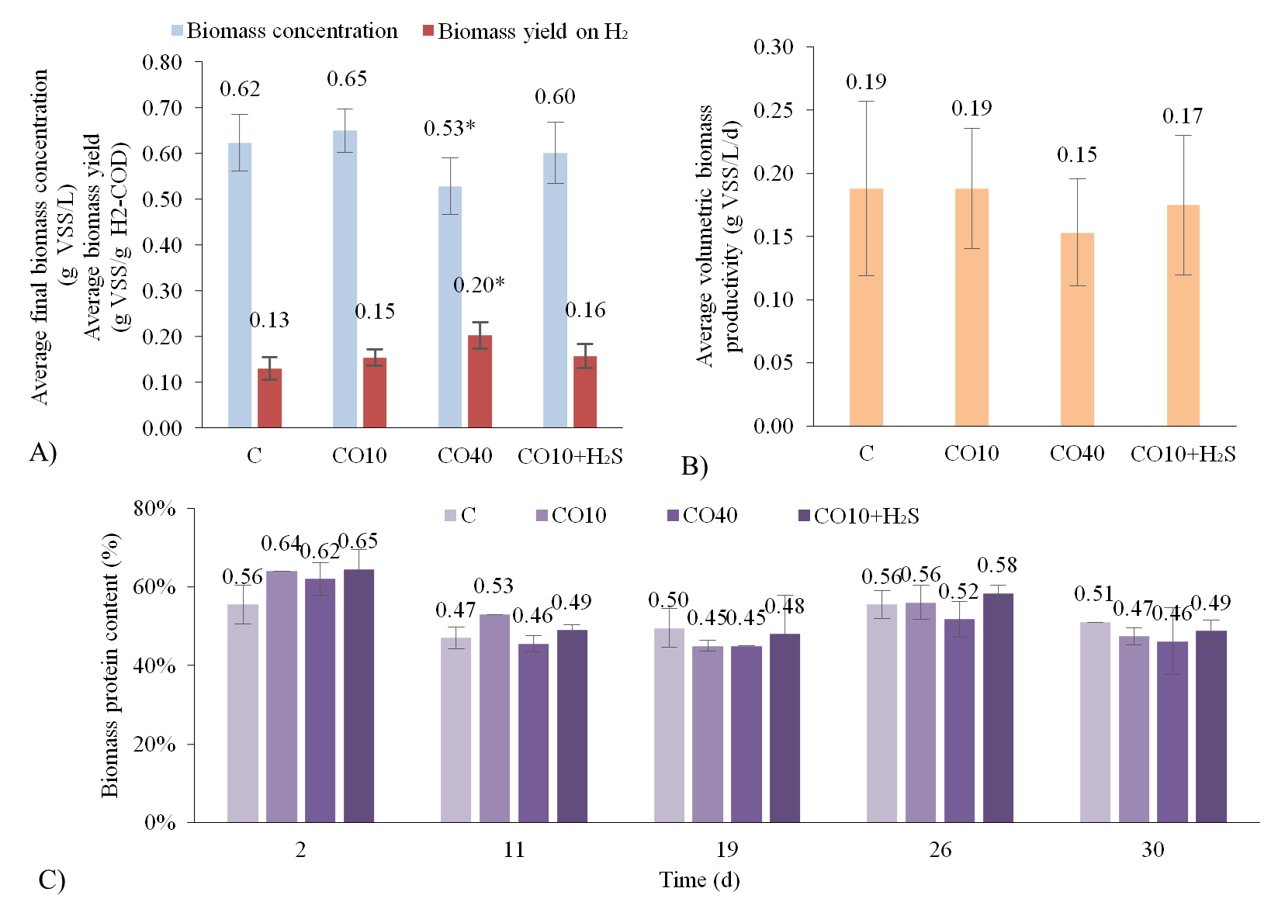
Fig. 1: Results of the long-term batch test in terms of A) average final biomass concentration and biomass yield, B) average volumetric productivity, and C) biomass protein content. *: statistically different value (p value < 0.05).

References
[1] N. Gao, K. Kamran, C. Quan, P.T. Williams, Thermochemical conversion of sewage sludge: A critical review, Prog Energy Combust Sci. 79 (2020) 100843.
[2] X. Sun, H.K. Atiyeh, R.L. Huhnke, R.S. Tanner, Syngas fermentation process development for production of biofuels and chemicals: A review, Bioresour Technol Rep. 7 (2019) 100279.
[3] M. Areniello, S. Matassa, G. Esposito, P.N.L. Lens, Biowaste upcycling into second-generation microbial protein through mixed-culture fermentation, Trends Biotechnol. (2022).
[4] S. Matassa, S. Papirio, I. Pikaar, T. Hülsen, E. Leijenhorst, G. Esposito, F. Pirozzi, W. Verstraete, Upcycling of biowaste carbon and nutrients in line with consumer confidence: the “full gas” route to single cell protein, Green Chemistry. 22 (2020) 4912–4929.
[5] N. Gao, J. Li, B. Qi, A. Li, Y. Duan, Z. Wang, Thermal analysis and products distribution of dried sewage sludge pyrolysis, J Anal Appl Pyrolysis. 105 (2014) 43–48.
[6] R. Han, C. Zhao, J. Liu, A. Chen, H. Wang, Thermal characterization and syngas production from the pyrolysis of biophysical dried and traditional thermal dried sewage sludge, Bioresour Technol. 198 (2015) 276–282.
[7] A. Jaramillo-Arango, I. Fonts, F. Chejne, J. Arauzo, Product compositions from sewage sludge pyrolysis in a fluidized bed and correlations with temperature, J Anal Appl Pyrolysis. 121 (2016) 287–296.
[8] S. Xiong, J. Zhuo, B. Zhang, Q. Yao, Effect of moisture content on the characterization of products from the pyrolysis of sewage sludge, J Anal Appl Pyrolysis. 104 (2013) 632–639.
[9] Y. Jiang, X. Yang, D. Zeng, Y. Su, Y. Zhang, Microbial conversion of syngas to single cell protein: The role of carbon monoxide, Chemical Engineering Journal. 450 (2022) 138041.
[10] J. Yu, A. Dow, S. Pingali, The energy efficiency of carbon dioxide fixation by a hydrogen-oxidizing bacterium, Int J Hydrogen Energy. 38 (2013) 8683–8690.
[11] S. Matassa, W. Verstraete, I. Pikaar, N. Boon, Autotrophic nitrogen assimilation and carbon capture for microbial protein production by a novel enrichment of hydrogen-oxidizing bacteria, Water Res. 101 (2016) 137–146.

